Transact – Transaction Search Job Aid
- Log in to Transact using single sign-on URL:
  - Https://webauth.cashnet.com/incadmin/Shibboleth.sso/Login?entityID=https%3A%2F%2Fvm-shibboleth.umb.edu%2Fidp%2Fshibboleth
- Click on Find Transactions
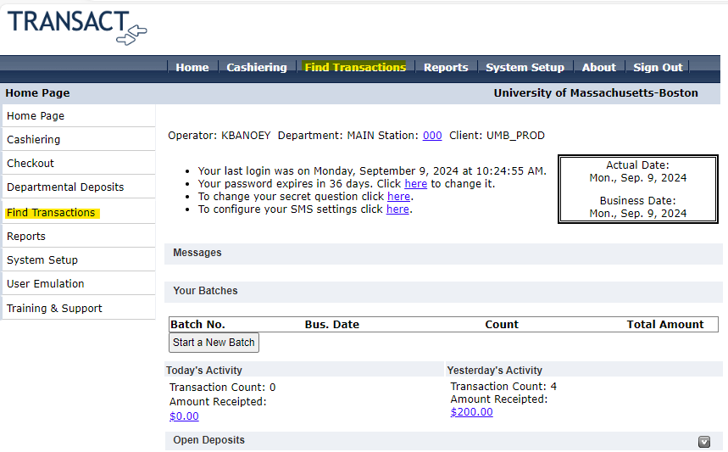
- Enter in the date range desired and click on “Find.”
