Transact – Reporting Job Aid
- Log in to PS Finance and select General Ledger & Budget

- Click on Review Ledger Information under Review Financial Information
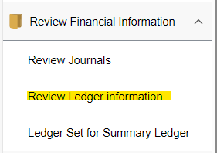
- Click on Add a New Value tab and add an inquiry name and click on Add
- Fill in the data as shown below and ensure to enter the correct account, department, fund, and program for your department and hit Save once all set.
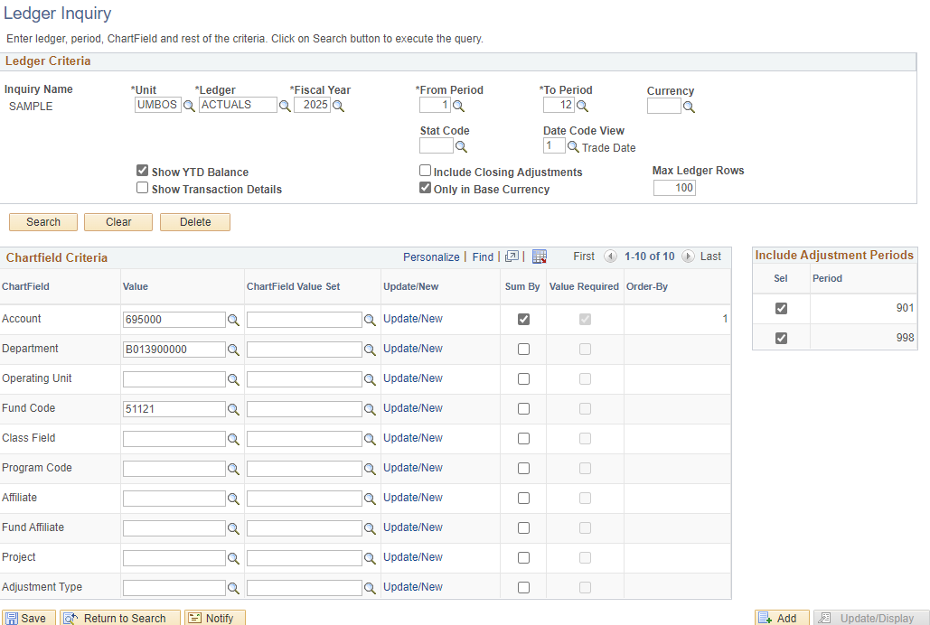
- Once Added, go back to Find an Existing Value, Click on Search and select the inquiry created.
- Once the inquiry has been selected, click on the search button
- Select the fiscal year accounting period that needs to be reconciled and click on Activity.
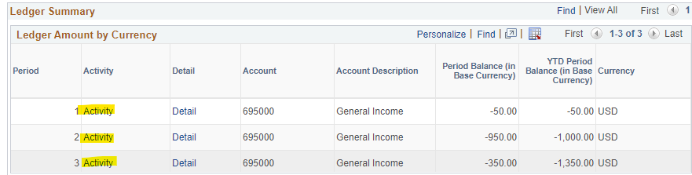
- Click on the highlighted icon to download the data into excel
- Disregard or delete the other non-Transact entries for reconciliation purposes.
- Take a total of items to be reconciled, for this example, the total is $150.
- Run a Transact report to generate monthly activity for the department.
  - For assistance to produce Transact report, please see Transact Report Generation Job Aid.
- Compare and contract to ensure totals match with PS Finance report, which is does in this example.
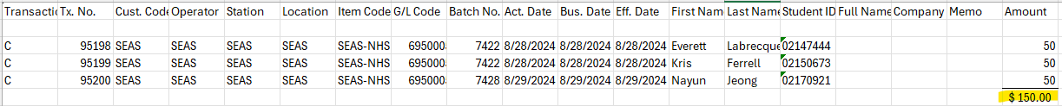
- Copy and paste data for both reports into one excel spreadsheet with two separate tabs containing both (see below example) and save file.


