- You will receive a notice of your new student bill availability via email sent by the Bursar’s Office (bursar@umb.edu) to your firstname.lastname001@umb.edu account.
WISER – eBills Job Aid
Bursar’s Office

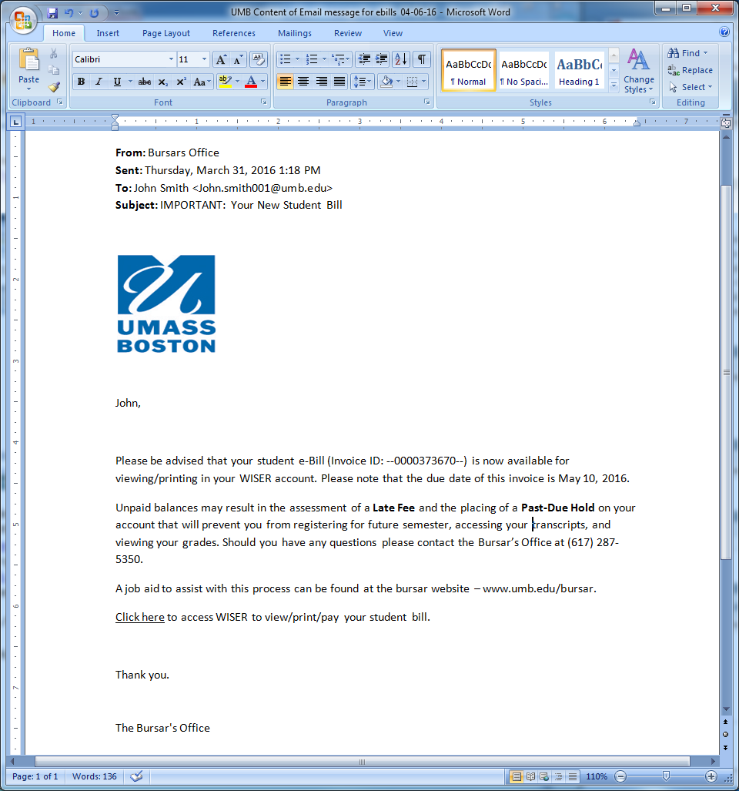

- Log into your WISER account to view/print/pay your student bill.
If you have forgotten your password, you can reset it by using https://mypassword.umb.edu.
If you have other questions regarding your WISER, please click https://www.umb.edu/it/getting_services/wiser/wiser_help_for_students for the tutorials and information.

- Once logged into WISER, click the “View All Invoices’ link on the Student Center.

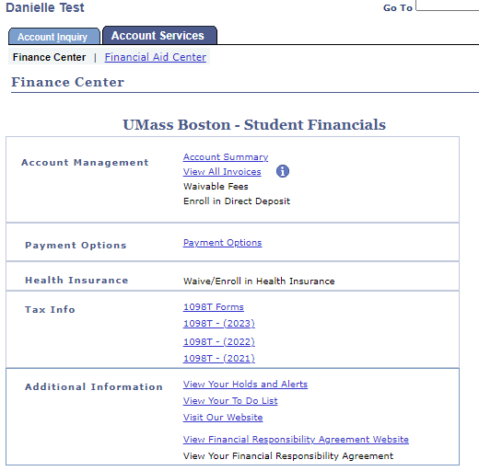

NOTE: Any new billing activities after the invoice date will not be reflected on the current bill, such as payments or the removal of waivable fees. New billing activities will be updated in the next time billing cycle, and then a new email message will be sent to you indicating a new e-Bill is available for viewing. All activities can also be viewed by clicking on the ‘Account Summary’ page located in the Finance section of your WISER account.

- A new page will open with a list of all your invoices from July 1st and forward, by date created. Select the view invoice link on the e-Bill you would like to view/print.

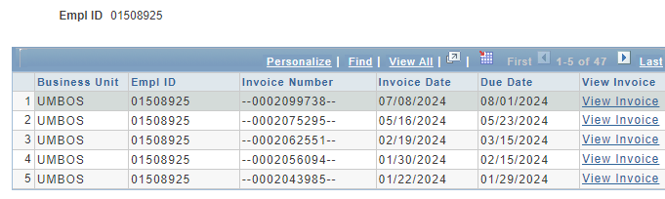

- The student invoice selected displays as a PDF file.

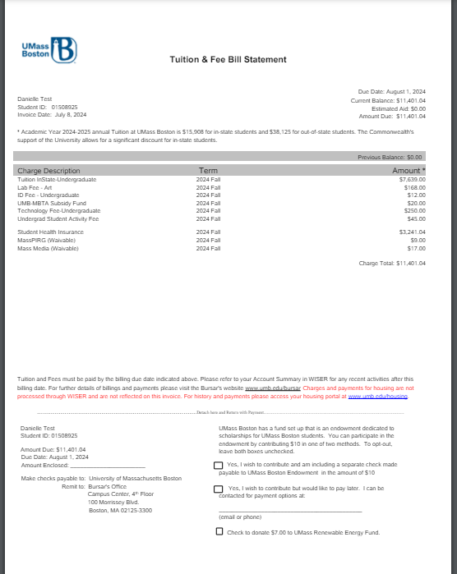

NOTE: You can save the invoice file to your computer and send it as an attachment in an email message to a parent, guardian, sponsor or employer. You can also print the file locally from your computer. You have the ability to grant a parent/guardian/sponsor access to your e-Bill in WISER.

- You have the choice to make a payment online using a credit card or e-check. Click on the ‘Make online ACH payment’ link or ‘Make online credit card payment’ link.

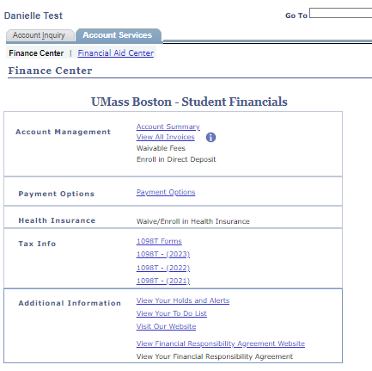

NOTE: Online payments are posted onto your student account within 1-2 business day.

- End of Procedure.
If you have any questions or concerns, please contact Bursar’s Office at 617-287-5350, send an email to bursar@umb.edu, or visit the bursar website at www.umb.edu/bursar.

