


Module 0: Ready to Learn



ACKNOWLEDGEMENTS

Thank you to all who participated in the development of this document. We are grateful for their time, commitment, ideas, and thoughtful dialogue and research. Without their efforts, this curriculum alignment could not have been completed. This alignment was a partnership between the Lowell Public Schools, Curriculum, Instruction and Assessment, and the University of Massachusetts Boston, Institute for Community Inclusion, thanks to funding from the Improving Teacher Quality Grant, which funded the Higher Order Teaching Grant (H.O.T). We are thankful for the additional collaboration of staff from CTI Head Start and Little Sprouts for their participation and contributions to our work.
- Tracy Bowers, Preschool Teacher, Lowell Public Schools
- Paula Bransfield, District STEM Support Specialist, PreK-12, Lowell Public Schools
- Kelly Devereaux, Preschool Teacher, Lowell Public Schools
- Tracy Genest, Preschool Teacher, Lowell Public Schools
- Julie Gordon, Preschool Teacher, Lowell Public Schools
- Shannon Green, Preschool Teacher, Lowell Public Schools
- LeAnne Hubert, Community Team Work Inc.
- Taryn Jacques, Little Sprouts
- MaryLu Love, University of Massachusetts Boston, Institute for Community Inclusion
- Alison Marchetti, Little Sprouts
- Patricia Murphy-Painchaud, District Support Specialist, Lowell Public Schools
- Melissa Newell, Coordinator of Language and Literacy PreK-4, Lowell Public Schools
- Terry O’ Neill, District Support Specialist, Lowell Public Schools
- Efrain Ponce, Little Sprouts
- Sandra Putnam-Franklin, Editor, University of Massachusetts Boston, Institute for Community Inclusion
- Martha Robey, Early Childhood Consultant, Lowell Day Nursery.
- Magaly Ronan, Coordinator of Mathematics PreK-4, Lowell Public Schools.
- Charlene Tutein, Kindergarten Teacher, Lowell Public Schools.
- Paula Tye-Flagler, Preschool Teacher, Lowell Public Schools
- Lisa Van Thiel, University of Massachusetts Boston, Institute for Community Inclusion
- Dorna Walsh, Kindergarten Teacher, Lowell Public Schools
- Anya Weber, Editor, University of Massachusetts Boston, Institute for Community Inclusion

INTRODUCTION
The Preschool Curriculum Modules for Lowell Public Schools were developed through funding from the Board of Higher Education, Title II, in collaboration with the University of Massachusetts Boston. Funding was provided for a group of early educators including Lowell Public Schools, Community Team Work Inc. and Little Sprouts to meet on a regular basis for over two years to develop units of study relevant to the students of Lowell.

Evidence-based practices such as Dialogic Reading, explicit and embedded instruction in phonemic awareness, concepts of print, and mathematics were embedded in units of study. Topics in science & technology, social & emotional learning, history & social sciences are also central to each curriculum unit, covering the scope of standards in the Massachusetts Curriculum Frameworks. Through these units of study, as children explore rich content over a prolonged period of time, they build on their background knowledge and develop new vocabulary and academic language as they construct new understandings of the world around them.

Guiding Principles
The following guiding principles were established to guide educators work as they developed these units.
- Differentiated Instruction: ALL children are capable of learning and must have access to a high quality, rigorous curriculum to foster learning.
- Intentional Teaching: Preschool teachers provide intentional instruction, through carefully sequenced lessons that expose children to new learning, facilitate exploration, and assist children in mastering new skills and knowledge.
- Resources: Educators model academic concepts and social-emotional skills by deliberately choosing and presenting resources to support children’s learning in the classroom across a variety of settings - whole group, small group, and center time.
- Equity for All: Preschool teachers recognize, celebrate, and build upon differences among students, drawing upon each individual’s culture, background knowledge, and language, to intentionally plan instruction to support all students in developing new skills and knowledge.
- Progress Monitoring & Assessment; Curriculum Planning and Program Evaluation: Preschool teachers use formative and summative data to reflect on children’s progress in academic and social-emotional skills and to reflect on their own teaching practices that impact outcomes for all learners.
- Promoting Positive Classroom Environments: Educators establish an enthusiastic learning environment that stimulates connections between and among children and adults while cultivating students’ approaches to learning, social-emotional well-being, and academic success.
- Family and Community Engagement: Families, the community, and schools are partners in collaboratively fostering all students’ growth.

Curriculum Map
The process of designing the curriculum modules included development of a grade level map in which the Massachusetts’ Curriculum Frameworks in English Language Arts, History & Social Sciences, Science, Comprehensive Health, and the Arts are used to guide student learning. Within each module, these standards are shown in bold italics.

The scope and sequence of Building Blocks®, and Handwriting without Tears® were integrated to provide instruction in mathematics, and in fine motor development and handwriting.

In Module 0 there is a strong focus on the Massachusetts Standards for Preschool and Kindergarten Social and Emotional Learning and Approaches to Play and Learning [see: http://www.doe.mass.edu/kindergarten/SEL-APL-Standards.pdf] as well as guidance from the Center for Social Emotional Foundations for Early Learning (CSEFEL) [see: http://csefel.vanderbilt.edu/resources/training_preschool.html]. This guidance sets the stage for creating supportive classroom environments that promote and build relationships in the classroom. Subsequent modules provide opportunities for children to develop executive functioning skills and social-emotional skills such as self-regulation, focusing attention, and persistence, while establishing friendships and learning how to be a member of a group. Teachers are encouraged to revisit module 0 and the resources on social and emotional learning throughout the year.

Daily Schedule
The following components are expected to be part of the daily schedule. The following recommendations are for implementation in a half-day program (two and half to three-hours).
- First Circle/Dialogic reading: 20-30 minutes
- Introduction to Centers: 10-15 minutes
- Centers: 60 minutes
- Small Groups: 15 minutes in Fall; 20 minutes in Spring (held during center time twice a week for English Language Arts and Mathematics)
- Outdoor Play or Gross Motor and Movement: 30 minutes
- Routines (including breakfast, snack, lunch and transitions): 30 minutes
- Second Circle - science, phonemic awareness, concept of print, social emotional learning, and community building: 30 minutes

The following recommendations are for implementation in a full day program (six hours or longer).
- First Circle/Dialogic Reading: 20-30 minutes
- Introduction to Centers: 10-15 minutes
- Centers: 60 minutes
- Small Groups Mathematics: 15 minutes in Fall/20 minutes in Spring [four times a week - two groups with adult support and one group engaged in independent, low support activity]
- Small Groups English Language Arts: 15 minutes in Fall/20 minutes in Spring [four times a week; two groups with adult support and one group engaged in independent, low support activity]
- Outdoor play or Gross Motor & Movement: 30 minutes
- Routines including breakfast, snack, lunch, transitions, and rest time: 3 hours
- Second Circle: Science, phonemic awareness, concept of print, social emotional learning, and community building: 30 minutes

Learning Centers
Child choice and accessible material that promote learning must be made available for a minimum of 30 minutes per day for half day and 60 to 90 minutes for full-day programs. Intentionally planned and implemented learning centers/opportunities must be provided daily, including:
- Art
- Easel
- Writing
- Manipulatives
- Blocks
- Math
- Science
- Sensory
- Library
- Dramatic Play
- Music/Movement
- Outdoor or active gross motor play
- Computer or listening center

Supporting Early Language and Literacy
Each of the modules includes resources for teachers for supporting early language and literacy:
- Book Sheets: Each module includes book sheets that provide suggestions for prompts and vocabulary development that adults can use with the various books highlighted in the module.
- Tiered Vocabulary Lists: Each module includes an extensive list of vocabulary words, categorized as “tier 1, 2, or 3” that have been drawn from the books used in the module. Key words can be defined before and during reading. It can also be useful to insert synonyms to extend thinking and learning (e.g., to extend the word problem, you might add words such as mistake, disaster, catastrophe, emergency, etc.). The meaning of words can also be highlighted using gestures or by varying the tone of voice or pacing of reading.

Dialogic Reading
Dialogic reading is a research-based strategy that has been proven effective. It expands interaction between the adult and child. It can be done by teachers or parents, and is simply about children and adults having a conversation about a book.

Typically, when adults share a book with children, the adult reads and the child listens. In dialogic reading, the adult helps the child become the storyteller. The child takes an active role while the adult listens and asks meaningful questions, and scaffolds the child’s processing of the story. The key to an effective and productive read-aloud is stimulating the child’s active engagement and making it fun.

This engagement involves interaction between the adult and the child, using various prompts. There are two sequences of prompts that the adult uses in dialogic reading, described by the acronyms PEER and CROWD. These sequences were developed by Grover J. (Russ) Whitehurst. A detailed explanation of these acronyms may be found in “Dialogic Reading: An Effective Way to Read to Preschoolers” which may be accessed at: http://www.readingrockets.org/article/dialogic-reading-effective-way-read-preschoolers.

The PEER sequence is a short interaction when the adult:
- Prompts the child to say something about the book,
- Evaluates the child's response,
- Expands the child's response by rephrasing and adding information to it, and
- Repeats the prompt to make sure the child has learned from the expansion.

The CROWD sequence describes five types of prompts used by the teacher:

Completion prompts: Leave a blank at the end of a sentence and get the child to fill it in. These are easy to use in books with rhyme or repetitive phrases (e.g., “Jack and Jill went up the ____”).

Recall prompts: These are questions about what happened in a book a child has read or listened to (e.g., “Can you tell me what happened to ___ in this story?”). These help children in understanding plot and describing sequences of events. They can be used at the end of a book, or at the beginning of a book a child has heard before.

Open-ended prompts: These prompts focus on illustrations in books (e.g., “Tell me what’s happening in this picture.”). They help children increase their expressive fluency and attend to detail.

Wh- prompts: These prompts usually begin with “what, where, when, why, and how” questions, and usually focus on the pictures in books (e.g., “What’s the name of this?”). These prompts teach children new vocabulary.

Distancing prompts: These prompts ask children to relate the pictures or words in the book to experiences outside the book (e.g., “Remember when we went to the farm? Which of these animals did you see there?”). Such prompts help children connect books to the real world and also help with verbal fluency, conversational abilities, and narrative skills.

Repeated Interactive Read-Alouds
The most effective use of children’s literature relies on intentional planning and follow-up, including introducing and defining new vocabulary before and during reading, and reinforcing and extending it after a read-aloud. Book reading is most effective when it is not limited to a single reading.

Repeated interactive read-alouds allow teachers to scaffold children's understanding of the book. They model strategies for making inferences, describing things and events, explaining reasons for their thinking. They also teach new vocabulary and concepts. These techniques have shown to be effective in increasing children's engagement, understanding, and appreciation of literature in preschool and kindergarten settings. There are three levels of interactive read-alouds:
- First reading: The main goal of a the first read-aloud is to enjoy a story by focusing on its meaning. The teacher introduces the plot with a sentence or phrase (e.g., “This story is about…”). The teacher reads the story using vocal and facial expression, gestures and dramatic pauses, variations in the pace of reading, and eye contact to capture and maintain children's interest and enjoyment,
- Second reading: Second readings occur a day or two after first reads. The purpose is to enrich children's comprehension of the story. The teacher encourages children to remember things from the book, provides vocabulary explanations, and asks inference and explanation questions. the second read might focus on the other characters' motivations or though
- Third reading: children are guided in retelling the story as the teacher reads some of the text. Teacher comments and questions are intended to generate children’s explanations about the causes of events and what characters are thinking or feeling (e.g., “Why does he think?” “How do you think she’s feeling?”). They allow children to use analytic thinking to explain why events occurred.

After-reading Discussions
Each reading is followed by a "why" question that requires children to make inferences about and explain several story events. Then we use follow-up probing questions to support children's ability to answer broader explanation questions.

This process is explained in detail in an article “Repeated Interactive Read-Alouds in Preschool and Kindergarten” by Lea M. McGee and Judith Schickedanz found at: http://www.readingrockets.org/article/repeated-interactive-read-alouds-preschool-and-kindergarten.

Motor and Neurosensory Development
One area of development that is often overlooked or not directly planned for in early childhood programming is motor and neurosensory development, yet it is critically linked to learning, especially reading and writing.

Scientific research has shown a strong connection between physical activity/movement and brain circuitry. The early years, from birth to age five, are a critical period for both brain and body development. Sensory-motor activities can be embedded throughout the child’s daily experiences. These include large motor activities that build strength, control, and coordination, as well as experiences that support smaller muscles in the hands and fingers.

While these kinds of activities are referenced throughout the curriculum modules, they can be further supported on an ongoing basis within the classroom, as well as through planned and facilitated outdoor play.

The Appendix for each module includes a section entitled “Supporting Motor and Neurosensory Development,” which includes suggestions for activities, and teachers are encouraged to share this information with families.
Lowell Public Schools in Partnership with University of Massachusetts -Boston |  | Timeline: Weeks 1 -2
Module Theme: "Ready to Learn" - From a Sense of Self to a Sense of the World
Module Overview: During the first weeks of school, teachers, families and students begin to create a sense of community by focusing on each individual's self-identity, or the capacity to advocate for one’s self, culture, values, and beliefs to create a democratic classroom where ALL can thrive and learn. Teachers do this by establishing routines, planning transitions, involving children in developing classroom rules and expectations for behaviors in various contexts, as well as by scaffolding interactions among children, and by guiding individual and groups in the use of conflict resolution strategies, thus facilitating social competence. Teachers set the stage for the classroom environment by modeling organization of space and materials, and by creating centers that are engaging, and that transition across the year using various themes. In the early weeks, activities are centered around easing the transition to school and separation from caregivers, introducing the children to the classroom environment, schedules, routines, rules, and expectations. Children explore centers and engage in hands-on learning experiences. Teachers collaborate with families to promote and enhance each child's social and cultural knowledge.
Essential Questions:  - What is a community?  - How is a community created?  - How would I describe myself?  - What are other ways we can describe ourselves and others?  - What is my identity?  - What is culture?  - What are values?  - What are beliefs?  - What is a routine?  - What are expectations?  - What is a transition?  - What is a rule?  - What is independence?  - What are emotions? Feelings?  - How do these apply to centers?  Ask children for examples. | Key Understandings:  - Communities come in all shapes and sizes. Communities are similar in that a community is a group of people living in the same place, or that have common characteristics. Community is also a feeling of belonging with others, because of the sharing of common attitudes, interests, and goals.  - A community is created through:  a. Consensus  b. Vision - What do we believe and want?  c. Knowing what you need to know  d. Clear agreements, in writing  e. Strong communication skills  f. Inclusion  - Identity defines who someone is, such as the name of a person, or the qualities, beliefs, etc. that make a particular person or group different from others.  - Culture includes the beliefs, customs, art, etc. of a particular society, group, place, or time.  - Values are beliefs that are useful or important to self and others.  - Beliefs are feelings of being sure that someone or something exists, or that something is true; a feeling that something is good, right, or valuable, or a feeling of trust in the worth of something or the ability of someone.  - Routine is a regular way of doing things in a particular order.  - Expectation is a belief that something will happen or is likely to happen; a feeling or belief about how successful, good, etc. someone or something will be.  - Transition is a change from one place or condition to another.  - Rules are words or sentences that tell you what is or is not allowed in a particular, place, game, situation, etc.  - Independence is freedom from the control, influence, support, or aid of others.  - Emotions are natural, instinctive states of mind deriving from one's circumstances, moods, or relationships with others; feelings that occur naturally rather than as a result of reasoning or knowledge.
Module Objectives:
- Teachers will introduce children to the physical environment and learning materials.
- Teachers will provide children with visual and auditory cues to learn sequence of the daily and weekly schedule of the classroom.
- Children will engage in social interactions with adults and peers.
- Children will identify classmates and teachers by name.
- Children will demonstrate caring for the classroom community by following class rules, expectations, and participating in clean-up.
- Children will begin to develop a sense of community and belonging by identifying and understanding their individual culture, beliefs, and values as well as those of the adults and peers.
- Children will begin to develop self-awareness, self-management, social awareness, relationship skills, responsible decision-making, and positive approaches to playing and learning.
- Children will begin to develop foundational reading skills of print concepts, phonological awareness, speaking and listening, and vocabulary use.
- Children will begin to develop an understanding of routines, problem solving, independence, and self-help skills.
- Children will begin to develop counting and cardinality principals, comparative and positional language.

.

Differentiation, Modification/Accommodations, Sheltered Instruction for All
Strategies designed to support children with disabilities or exceptional learning needs are likely to benefit all children with a range of abilities or background experiences. Some children may have Individual Education Plans (IEPs), but for many children, especially those who have not previously have been in group settings with peers, their developmental or learning needs may not yet have been diagnosed. It is therefore critical that teachers and caregivers observe children carefully and plan experiences with a broad perspective.

What could you do to support dual language learners and children with disabilities or exceptional learning needs in accessing the curriculum?
- Model tiered vocabulary using visual and physical cues, picture word charts; extend processing time/wait time.
  - Talk and move: Repeat and restate in own words using single words, phrases or complete sentences; use movement to illustrate definition of words.
  - Highlight key vocabulary for DLLs throughout the day.
  - Provide students with structures to use new vocabulary (e.g., use sentence frames and sentence stems, etc. to facilitate children’s use of oral language). This should be done in the context of conversations and authentic activities in which children are actively engaged.
  - Engage children in conversations during routines and meals to reinforce new vocabulary.
  - Use engaging informational texts as a platform for intensive vocabulary instruction, limit to a few academic terms for intensive vocabulary instruction.

Resources: Each module’s Appendix will include information about WIDA Standards.
- WIDA Standards: The Early English Language (E-ELD) and Early Spanish Language (E-SLD) Development Standards (2014) are designed for use by early childhood practitioners, including child care, Head Start, preschool/prekindergarten educators, and caregivers. These can be accessed at https://www.wida.us/standards/EarlyYears.aspx. The purpose of these E-ELD standards is to provide a developmentally sound framework for supporting, instructing, and assessing dual language learners (DLLs), ages 2.5-5.5 years.
- WIDA “CAN DO” descriptors: These descriptors highlight what language learners can do at various stages of language development as they engage in teaching and learning in academic contexts. These can be accessed at https://www.wida.us/standards/CAN_DOs
- The website for the Center on the Social and Emotional Foundations for Early Learning (CSEFEL) provides resources on supporting children with challenging behaviors. See: http://csefel.vanderbilt.edu/resources/training_preschool.html.

What adaptations and modifications must be made to support children in your class?
- Ensure that the environment supports inclusion of children with diverse learning needs. See “Building Supportive Environments: Companion Document to the Massachusetts Standards for Preschool and Kindergarten for Social and Emotional Learning and Approaches to Play and Learning” at http://www.doe.mass.edu/kindergarten/SEL-APL-Env.pdf
- Adapt the physical or social/emotional environment to match the learners in your class. For students with vision or hearing impairments, students with physical disabilities, and/or cognitive/language delays, such as:
  - providing preferred seating
  - scaffolding directions/activities
  - providing visual supports for communication (using illustrations to communicate needs and ideas)
  - providing visual supports for multiple steps
  - modeling by peers/adults
  - providing resources/manipulatives accessible to learners
  - using frequent check-ins for understanding
  - using practice/repetition; connecting new learning to prior knowledge/experience
  - promoting peer tutoring
  - simplifying choice boards
  - providing activities that build and support all children’s motor and neurosensory development, including gross and fine motor skills (e.g., strength, balance, agility, position in space, visual perception, visual discrimination, hand strength and coordination, finger dexterity, scissor skills). Also see Appendix section on Supporting Motor and Neurosensory Development.

How will you use observation and assessment to inform instruction to promote each child’s development of social skills and relationships, communication, and concepts & skills?
- Plan to observe and document specific learning skills each week.
- Develop systems to ensure that data is collected on all children.
- Use data to inform small groups and establish timelines for regrouping based on data.
- Provide “Response to Intervention” groups at least weekly for children needing additional support in language/literacy and/or mathematics.

How can you make the curriculum accessible to ALL children?
- Apply the seven principals of Universal Design for Learning (UDL).
  - Incorporate multiple engagement opportunities for children to engage in whole and small group activities and to practice them in centers.
  - Provide multiple means for children to communicate their ideas through gestures, pictures, words, and print.
  - Pair students with peers with similar abilities in small group activities; pair students with stronger skills with children that need more assistance during centers.
  - Consider a variety of ways for students to interact with content presented in various instructional learning formats.
  - Use photographs or video to provide background knowledge in advance of the lesson.
  - If available, use an interactive white boards or other technology to generate students' excitement.
  - Use hands-on, active engagement strategies to support learners (e.g., while describing characteristics of a triangle, point to sides and corners and allow students to touch and count the sides the corners; when using positional words, support learners by using a template that models the correct position; use physical demonstration to define and illustrate action words).

Other suggestions:
  - Equitable use: Enable all users equal access to avoid segregation. Consider flexibility in use to accommodate a wide range of individual preferences and abilities.
  - Ensure that curriculum is easily understood by all language levels.
  - Adjust the complexity of presentation based on progress monitoring.
  - Use multiple means of presentation to engage children (pictures, verbal, tactile, movement).
  - Focus on success and engagement; eliminate barriers; provide a supportive environment that provides ongoing assistance, builds on background knowledge, and scaffolds instruction to teach “Big Ideas” through tolerating errors.
  - Accommodate student perspective, comfort, motivation, and engagement based on children’s responses and progress monitoring data.
  - Ensure that the environment is appropriate and organized to allow physical and cognitive access to instruction, environment, and grouping.
  - Incorporate student interests into centers and activities.
  - Promote the processes of exploration, investigation, and discovery.
  - Provide students with choices for engaging with the curriculum by offering multiple activities that incorporate the same objective.
  - Provide adjustable levels of challenge.
  - Allow sufficient time for children to fully explore and practice.
  - Choose books, materials and activities that are sensitive and responsive to diversity.

Center Connections:
- Library Center: Include books that reinforce and extend concepts presented in each module (e.g., have students search for triangles and non-triangles using obvious and not so obvious shape books).
- Create a center/space where children can practice skills and concepts highlighted in the module.
- Provide extensions or challenges for students who are working above grade level, such as encouraging them to trace objects.
- Create opportunities for children to use key vocabulary words in the classrooms and they are actively engaged.

Teacher Reflection
Effective teaching means teaching intentionally, and reflecting constantly – both planning ahead and looking back. Teacher reflection impacts the next level of planning and teaching intentionally. If all the children did not have the necessary skills or knowledge for an activity, consider what could have been done differently to prepare for the activity. When an activity is over, consider the following questions:
- Did all the children have the necessary skills/knowledge for this activity?
- Were all the children engaged?
- Who was not? Why?
- What did you observe about the group? Individual children?
- What needs to happen next?
- How will we accomplish it?

See Appendix in each module for additional information on supporting Dual Language Learners/English Language Learners.

Tiered Vocabulary for Module 0
Tier 1 | Tier 2 |  | Tier 3
Bathroom/Restroom  Clean-up  Cafeteria  Gymnasium  Name/s of peers/adults/places  Playground  Snack/lunch  Feeling words  Angry/Mad  Calm  Frustrated  Happy  Relax  Sad  Scared/Afraid  Manner Words  Apology/Sorry  Excuse me  Please  Thank you  Greeting Words  Good morning/afternoon  Goodbye  Welcome  Number Names and Symbols  Zero (0)  One (1)  Two (2)  Three (3) | Action  After  Block  Backpack  Center/s  Choice  Collection(s)  Community  Compare  Count  Describe  Different  Expectations  Familiar  Group  Hang up  Identity  Interest  Listen to  Line/up  Learned  Mat/cot  Numeral  Object  Position  Problem  Quantity  Question  Recognize  Rest  Routines  Rule/s  Safe/unsafe  Say | Scattered  Schedule  Share  Similar  Sink  Size  Sort  Space/Personal  Statement  Strange  Thoughts  Turn/Take Turns  Table  Values  Warmth | Above  Apart  Barrel/Garbage/Trash can/bin  Beliefs  Below  Beside  Block Center  Carefully  Close to  Cubby  Digit  Dramatic Play Center  Equal to  Inside  Meeting Time/Circle Time  Thoughtful  More/less than  Next to  Promised  Same as  Sensory Table  Recycle Bin  Strange  Teacher’s Desk  Tingled  Unfolded  Water fountain  Writing Center  1 less  1 more

Week 1 | Day 1 | Day 2 | Day 3 | Day 4 | Day 5
First Circle: | 1st Read  The Kissing Hand  Audrey Penn  - What are value, beliefs, routines?  - What is a transition?  - What is independence?  - Have you ever felt worried about trying a new thing?  - What new things have you tried?  Standards:  APL.3  SEL.1  MA.RF.1a  MA.RF.1 | 1st Read:  If You Take a Mouse to  School  Laura Numeroff  - Have you seen this book before?  - What is the mouse doing?  - What do you think he will do next?  - What makes you think about school?  Standards:  APL.2  MA.RF.1a  MA.RF.1d | 2nd Read:  The Kissing Hand  Audrey Penn  Introduce activities and continue during center time (See CSEFEL  and Additional Resources)  - What are values, beliefs, and routines?  - What is a transition?  - What is independence?  - Where was Chester standing?  - What kinds of things will Chester do in school?  - What kinds of thoughts do you think he was having?  - What do you think it means to be thoughtful?  Standards:  APL.8  MA.L.1d | 2nd Read:  If You Take a Mouse to School  Laura Numeroff  - What do you do in the morning when you get ready for school?  - What do you bring to school in your backpack?  - What kind of work do you do in school?  - What kind of house does a mouse live in?  Standards:  MA.RF.2a | Read:  Revisit favorite story.
Second Circle: | Read:  CSEFEL: What Do We Do In  Circle? – Expectations for this routine.  http://csefel.vanderbilt.edu/scriptedstories/circle.html  - What is a community?  - How is a community created?  - What is a routine?  - What are expectations?  - What is a transition?  - What is a rule?  Standards:  MA.SL.1a  SEL.4  PK-K.6 | Science – Day and Night  Chart/Animals/Activities  What is a transition?  - Who is in the day community?  - Who is in the night community?  See Activity 1. | Read:  CSEFEL: What Do We Do in Circle? (action cards, role play…)  Expectations for this routine.  http://csefel.vanderbilt.edu/scriptedstories/circle.html  - What is a community?  - How is a community created?  - What is a routine?  - What are expectations?  - What is a transition?  - What is a rule?  Standards:  MA.SL.1a  SEL.4  PK-K.6 | Songs – Greeting, Getting to Know You etc.  - How would I describe myself?  - What are other ways we can describe ourselves and others?  - What is my identity?  - What is culture? | Songs – Greeting, Getting to Know You etc.
Handwriting without Tears | Introduce Week 2.
Introduction to Centers | Tour centers: Limit centers and introduce each day for children to learn how to use and take care of materials. Explain limits of number of children per center. |  | Close Tuesday’s centers and introduce new centers on Wednesday. | Close Wednesday’s centers and introduce new centers on Thursday. How many children per center? | Continue introducing centers until all have been open to children.

Mathematics Small Group 2 times per week | Whole group introduction first.  Sorting Mat with Attribute blocks by one attribute.  Puzzles - Puzzles – introduce flip, turn/rotate, slide, border  Standards:  PKG.MA.1  SMP (Standards for Mathematical Practices)  1, 3, 5 & 6
Language Literacy Small Group 2 times per week |  |  | Kissing Hand Activity – Trace children’s hand and use sentence frame handout to create a class book or a class bulletin board.  - What is a community?  - How is a community created?  - What is a transition?
Sensory | Prepare no-cook play-dough prior to introducing in small groups and explain the use, storage, and care of the play-dough.  Make connections to The Kissing Hand by having children make hand-prints and hearts.  Experiment with their hands (pounding, squeezing, squishing, pressing, rolling the play-dough).  Rules and Uses  Talk about and show children things they can do with the play-dough.  Talk about how it feels.  Describe texture.  Continue in small groups throughout.  Tools to be used with play-dough can be gradually added after children have experienced exploration with their hands  - cookie cutters  - small toys to hide in the play-dough  - add hearts or hand shape cookie cutters.  Introduce Water or Sand Table on Wednesday.  Standards:  SEL4 & 8  APL.1, 5 & 8  SMP (Standards for Mathematical Practices): 1, 3, 5 & 6
Science Area | Introduce Science Materials/class pet if you have one  – magnifying glasses, magnets, feeling box games.  Science – Day and Night Chart/Animals/Activities  - What is a transition?  - Who is in the day community?  - Who is in the night community?  SMP (Standards for Mathematical Practices) 1, 3, 4, 5 & 6
Manipulatives | Beads for stringing friendship bracelets. |  |  |  | Raccoon Puzzle
Math Center | Using beads, have the children string friendship bracelets and exchange with a friend whose name they have learned.  Zero – 3  - Form zero with fingers or fist.  - What does “0” mean?  - “0” Activity – Put out 4 paper plates. Number the plates 0 – 3. Write the numeral on each plate and place the corresponding number of stickers on the plate (i.e., ‘0’ no sticker on the plate, ‘1’ one sticker, ‘2’ stickers, ‘3’ stickers).  - Demonstrate placing the corresponding number of objects on each plate.  - Discuss why the plate with ‘0’ does not have any objects on it.  - Have the children place objects on the plates. Ask, how many? How did you know how many objects to put on the plate?  - Assess for students who are counting 1:1 or subitizing quantity.  Standards:  PK.G.MA.1  SEL.3, 7 & 8  PK.CC.MA.1-5  APL.1, 2, 3, 4 & 8  Number Sense 23, 24 & 25  Technology & Engineering 36  PK.CC.MA 1- 5  APL 1, 2, 3, 4, 8 |  |  |  | Puzzles (Math)  Raccoon Puzzle  Standards:  PK.G.MA  SMP (Standards for Mathematical Practices):  1, 3, 5 & 6
Art/Easel | First introduce activity with stencils and crayons – encourage children to trace hand and decorate with stencils.  Allow children to choose their hand kiss/stamp and tell you why they made the choice.  Ask child to describe their kiss/stamp.  Parent & Family Engagement Opportunity: Ask children to choose a special symbol along with a family member to represent their love and why they chose it. Provide families with the blank hand to create their special Kissing Hand symbol and bring to school to share.  Standards:  SEL.2, 4, & 7-10  APL.1-5 & 8  PK-K.19  PK.CC.MA.5
Gross Motor | Playing outside with friends, learning playground/gym rules, navigating gross motor equipment; music/dancing with friends.  Learning Activity – Ask students to SCAMPER like Chester.  Standards:  APL.5  SEL.4, 7, 8, 9 & 10
Writing | Continue the Kissing Hand Activity. Trace children’s hands and use sentence frame handout to create a class book or a class bulletin board.
Book Area | Let’s Count; I Love School!; Math Counts: Sorting; Kissing Hand and other class books that are related, if available.
Conversations during routines and meals | Friendship and Choice: (Connect to Friendship Bracelet)  - Discuss meaning of the words friends and friendship. Brainstorm ways to show you are a friend.  - Discuss activities that friends do together.  - “_______ and I like to do _______ together.”  - “________ and I do not like to do __________ together.”  - Do you sometimes make a different choice from your friend?  Standards:  SEL.3, 7, & 8  APL.1, 2, 3, 4, & 8  PK.CC. MA 1-5  PK.G.MA 1
Dramatic Play | Free exploration of the dramatic play area.  Teach rules of the area. How many children can play in the area? Talk about the reasons for limits (what might happen if too many children are in the area?) Talk about how to care for the materials and clean-up when done.  Encourage students to make meals for friends, sharing and learning manners.  Standards:  SEL.7-10  APL.1-8  MA.L.1b  PK-K.1
Blocks | Children’s Choice - Discuss rules and expectations, limits for building towers.  Standards:  SEL.3, 4 & 7-10  APL.1-8  PK.G.MA1  PK-K. 8, 17 & 19  PK.CC.MA 1-5
Computer &/or Listening Center | Computer center you may want to introduce during the 3rd week of school.  Listening center – Children’s choice with a friend.
Other

Week 2 | Day 1 | Day 2 | Day 3 | Day 4 | Day 5
First Circle: | 1st Read:  Pete the Cat: Rocking in My New Shoes  Eric Litwin  What do you see in the picture?  Standards:  SEL.4, 7 & 8  APL.1-3, 5 & 8  MA.RF.1a  MA.RF.1d  MA.RF.2a  MA.SL.1-3 | 1st Read:  Llama Llama Misses Mama  Anna Dewdney  What is independence?  Standards:  SEL.1-5, 7, 8 & 11  APL.1-5 & 8  MA.RF.1a  MA.RF.1d  MA.RF.2a  MA.SL.1 -3  PK-K.19 | 2nd Read:  Pete the Cat: Rocking in My New Shoes  Eric Litwin  - What is Peter boarding?  - Who is driving the bus?  - Did you ever ride on a bus?  - What is Peter wearing on his feet?  - What is he carrying?  - Etc.  Standards:  SEL.4, 7, 8  APL.1-3, 5 & 8  MA.RF.1a  MA. RF.1d.  MA.RF.2a  MA.SL.1-3 | 2nd Read:  Llama Llama Misses Mama  Anna Dewdney  What is independence?  Standards:  SEL.1-5, 7, 8 & 11  APL.1-5 & 8  MA.RF.1a  MA.RF.1d  MA.RF.2a  MA.RF.2b  MA.RF.2c  MA.SL.1-3  MA.L.1  PK.-K.19 | 3rd Read:  Llama Llama Misses Mama  Anna Dewdney  What is independence?  Standards:  SEL.1-5, 7, 8 & 11  APL.1-5 & 8  MA.RF.1a  MA.RF.1d  MA.RF.2a  MA.RF.2b  MA.RF.2c  MA.SL.1-3  MA.L.1  PK.-K.19

Second Circle: | School Rules  - Talk about rules and the  - reasons that we have rules in school.  - Talk about the ways that rules are used in school and have children develop a list of classroom rules (3-5) that cover the basics - respect, safety, organization. Talk about how to keep the classroom clean and organized.  Standards:  SEL.4 | I Can Be a Super Friend!  http://csefel.vanderbilt.edu/s  criptedstories/friend.ppt  CSEFEL book.  Whole group  Agree on class rules and Stop and Go examples.  Standards:  SE. 1-12  APL.5  MA.RF.1a  MA. RF.1d  MA.RF.2a  MA.L.1  PK–K.8 & 17 | - Talk about community and the reasons why a community is created; its values, beliefs, and expectations.  - Talk about the ways that rules are used in school and have children develop a list of classroom rule (3-5) that cover the basics in the classroom community - respect, safety, organization. Talk about how to keep the classroom clean and organized.  Standards:  SEL.4, 7, 8  APL.5 & 8  MA.L.1 & 4  PK.-K.6 | - I Can Be a Super Friend!  - CSEFEL 2nd Read Whole Group.  - Make connections to how rules help us be super friends, how rules help us create a happy, healthy, safe, and supportive learning community.  - Finalize agreed-upon class rules.  - Make connections between Super Friend characteristics, friendship bracelets, rules, and community to classroom management system, (e.g., Stop and Go Behaviors, Go for Green).  Standards:  SEL.1-12  APL 5  MA.RF.1a  MA. RF.1d  MA.RF.2a  MA.L.1  PK-K.8 & 17 | How have you felt this week leaving home and coming to school compared to last week?  Introduce Feelings Chart  Sing a few feeling songs.  Reflect on past two weeks of school – like/ didn’t like; still nervous about; frustrated, etc.  Standards:  SEL.1-12  APL.1-3, 5 & 8  MA.RF.1a  MA.RF.1d  MA.RF.2a  MA.L.1  MA.L.1d  MA.L.1e  MA.L.1f  MA.L.4  MA.L.5c  PK–K.8 & 17  PK-K.17

Handwriting without Tears | Readiness  Shake Hands, p.23 | Readiness  Shake Hands, p.23 | Pre-Writing  Polish, Sort & Trade Wood Pieces, p.87 | Alphabet Knowledge  ABCs on Sing Along CD, p.48 | Pre-Writing  Wood Pieces in a Bag, p.88
Handwriting without Tears | Pre-Writing  Wood Pieces with Music, p.85 | Sing Along CD  "Skip to My Lou" | Pre-Writing  Wood Pieces with Music, p.85 | Sing Along CD  "Ten Little Fingers," p.26 | Pre-Writing  Wood Pieces with Music, p.85
Introduction to Centers | Introduce your Center Choice Board system - Introduce if children are ready, if not, wait until week 3.  Standards:  SEL.4 & 7-10  APL.1-8  MA.RF.1a  MA. =RF.1d  MA.L.1b  MA.L.1d  PK-K.1, 6, 8, 17 & 19  PK.CC.MA. 1-5  PK.G. MA.1
Mathematics (Whole Group) | Quick images using dot cards 0 – 3. Teacher flashes a dot card for a few seconds and asks students to name the quantity with hands or words.  Standards:  SEL.4  AP. 1-6, 8  PK.CC.MA. 1, 3, 4
Mathematics Small Group 2 times per week | Kissing Hand Math Board Game or Kissing Hand Five Frame  Standards:  PK.CC.MA. 1, 3-5  PK.G.MA.1  SEL.1, 3-5, 7-10  APL.1, 2, 3, 6-8
Language Literacy Small Group 2 times per week | Kissing Hand Activity (continued from previous week if not yet completed).  - Trace children’s hand and use sentence frame handout to create a class book or a class bulletin board.  - What is a community?  - How is a community created?  - What is a transition? |  | CSEFEL Stop and Go Behaviors – Read this short book and use the resources to generate specific class examples of “Stop and Go” behaviors.  Standards:  SEL.1, 3-5, 7-10, & 12  APL.1-3, 6-8  MA.RF.1a  MA.RF.1d  MA.RF.2a  MA.L.1  PK–K.8
Sensory | Water or Sand: Buckets and shovels or buckets and turkey basters.
Science Area | Encourage students to collect specimens during recess or nature walks to bring back to the science center to examine and describe under the magnifying glasses.  Talk with children about the items they find. Encourage them to describe items and make comparison among items with one another. Encourage children to wonder and ask questions. Record children’s questions and refer back to them in upcoming weeks as curriculum focuses on topics of interest to children.
Manipulatives | Objects for counting. | Beads for stringing. | - Matching Mat or Five Frame.  - 0-3 Spinner or Number Cube.  - Objects for matching to quantity. | Beads for stringing. | Objects for counting.
Math Center | Count many different  Objects in a line 0 – 3  Standards:  PK.CC.MA. 1, 3, 4  SEL.3, 4 & 7  APL.1-3, 5, 7 & 8  MA.L.1  MA.L.1b  SMP (Standards for Mathematical Practices) 1, 2 & 4-6 | Continue using beads, have the children string friendship bracelets and exchange with another friend/adult whose  name they have learned.  Standards:  PK.G.MA.1  SEL.3, 7 & 8  APL.1-4 & 8  PK.CC.MA.1-5 | Matching Objects: Use  Matching Mat or Five Frame and 0 – 3 spinner or number cube. Have child match number of objects for the given quantity.  Standards:  PK.CC.MA. 1-4  SEL.3, 4, 7  APL.1-3, 5, 7 & 8  MA.L.1  MA.L.1b  SMP (Standards for Mathematical Practices) 1, 2 & 4-6 | Continue using beads, have the children string friendship bracelets and exchange with another friend/adult whose  name they have learned.  Standards:  PK.G.MA.1  SEL 3, 7 & 8  PK.CC.MA.1-5  PK.CC.MA. 5  APL.1-4 & 8 | Count many different  Objects in a line 0 – 3  Standards:  PK.CC.MA.1, 3 & 4  SEL.3, 4 & 7  APL.1-3, 5, 7 & 8  MA.L.1  MA.L.1b  SMP (Standards for Mathematical Practices) 1, 2 & 4-6

Art/Easel | Easel painting – red, yellow, green, and blue (large paper cut into shapes such as shoes or backpacks) |  | Pete the Cat – Coloring School Shoes and cut a circle around shoe.
Gross Motor | Count to 2 Chant – Clapping, jumping, etc.  Standards:  PK.CC.MA.1, 3 & 4  SEL.3, 4 & 7  APL.1-3, 5, 7 & 8  MA.L.1  MA.L.1b
Writing | Large crayons and paper. Stencils of numbers, letters, and shapes.  Practice Writing Numbers 0 – 3  Practice Writing Letters in names – quantify and compare quantity of letters in students’ names.  Standards:  PK.W.1, 2, 3 & 6  PK.CC.MA.1, 2 & 5  SMP (Standards for Mathematical Practices) 1, 5 & 6
Book Area | Rex Wrecks It! Ben Clanton  When I Build with Blocks, Niki Alling  Shapes, Shapes, Shapes, Tana Hoban  Cubes, Cones, Cylinders, & Spheres, Tana Hoban  Block City. Robert Louis Stevenson
Conversations during routines and meals | Friendship and Choice: (Connect to Friendship bracelet)  Discuss meaning of the words friends and friendship. Brainstorm ways to show you are a friend.  Discuss activities that friends do together.  “_______ and I like to do _______ together.”  “________ and I do not like to do __________ together.”  Do you sometimes make a different choice from your friend?
Dramatic Play | Continue free exploration  and area rules and  expectations. | Encourage students to play  pretend with dress up clothes and other items. | Model and encourage  children to set table for a tea party or make lunch for friends. | Encourage children to pretend to be a family or a community of new friends.
Blocks | Matching – blocks to label (exact match) |  |  | Sorting by one attribute – shape, size, or color
Computer &/or Listening Center | Computer center you may want to introduce during the 3rd week of school.  Listening center – Children’s choice with a friend.
Other

Appendix

Supporting Motor and Neurosensory Development

The large muscles of the body are critical to supporting the small muscles in the hands and fingers. If we want children to be able to hold a pencil and eventually write words and stories, they need to have the strength, flexibility, and coordination in all the muscles involved in the task. In addition, children need to develop skills that build their perception, in order to understand concepts such as up, down, over, under, beside, right and left, all of which are fundamental to learning to read and write.

Key motor and neurosensory skills include:
- Crossing the midline: The ability to cross the midline of the body is related to both reading and writing (moving smoothly from the left side of a page to the right and back again). It can be fostered by providing activities that promote arm movements that smoothly cross the midline, such as using a large chalkboard or whiteboard, or easel paper, to make large movements from left to right. It is also supported by providing two containers on either side of the body and having children transfer objects from one container to the other.
- Directionality: Children learn directionality and position in space through their own body experiences. They need to be able to understand and “feel” concepts of up, down, over, under, right and left, in order to be able to distinguish directionality in letters (e.g., the difference between a lower case p, d, b, and q). Spatial knowledge is critical to writing – the positioning of the shapes of specific letters within words can be complex, for example, in a word like “gargoyle” the letters extend above and below the writing line, and there are vertical, horizontal and diagonal components.
- Visual perception and visual discrimination: Visual discrimination refers to the ability to differentiate one object from another. For example, there may be two pictures on a page with small differences and a child must be able to distinguish the differences. These skills are supported and reinforced by sorting and matching activities that involve discriminating among a number of elements (e.g., blocks, beads, popsicle sticks, pegs on a pegboard), and reproducing patterns/arrangements. These kinds of activities also support mathematical thinking. The visual arts can be used to build many spatial, visual perception, visual discrimination, and visual motor skills.
- Visual motor skills: These skills are also referred to as hand/eye coordination, and include the ability to reproduce/represent shapes on paper. There are many materials and activities that can be used to build visual motor skills, such as:
- Following a line on paper with a crayon or marker;
- Pushing a car/train along a “track” (“streets” can be drawn on a long piece of paper);
- Using tools such as hammering nails;
- Stringing beads or macaroni on a string to make necklaces;
- Using blunt plastic needles to “sew” in and out of holes punched around a paper plate or through small squares of plastic needlepoint material;
- Rolling, tossing, and catching beanbags or foam balls of various sizes;

Gross Motor Development
As young children move their bodies, learn many concepts through their senses (sensory motor integration), so they need to be provided with many sensory-motor experiences that integrate body movements with the senses (tactile/touch; smell; hearing; taste; sight, and kinesthesia/ movement). These include visual-motor activities that integrate visual information with fine- and gross-motor movements (e.g., tossing, striking, kicking, and catching objects).

It is important to develop the upper body of shoulders and arms in order to support the smaller muscles in the hands and fingers (needed for writing). Physical development and outdoor play using large equipment are prime opportunities for intentionally supporting this development. Movement challenges can also be embedded in indoor activities that involve postural control, coordination of movements, and locomotion (e.g., crawling, creeping, body rolling, jumping).

Use of large equipment can help children to strengthen the upper body (e.g., push-ups and pull-ups, monkey bars, climbing through tunnels, obstacle courses, seat scooters). Upper body strength/control can also be built with pushing/pulling equipment such as wagons, or carrying a tray full of leaves with both arms, or movement activities such as making large, sweeping movements and circles using the entire arm. Using easels or wall-mounted chalkboards or white boards to make designs can also strengthen these muscles.

Fine Motor Development/Hand Skills
Hand Skills such as strength and dexterity begin with manipulatives. Young children need to spend more time with fine-motor manipulatives than with writing utensils, because their hands may not be ready for such refined activity. Many activities typically found in preschool classrooms are appropriate for building hand strength and dexterity. Examples of manipulative activities include:
- Using a hand hole punch to punch holes in increasingly heavy papers;
- Rolling, molding, squeezing clay and playdough using with hands or fingertips;
- Screwing lids on and off jars, screwing pipe fittings together, or assembling nuts and bolts;
- Building with large Lego blocks (Duplos) or other assembly toys;
- Picking up objects using household tools such as tongs;
- Using tweezers or “strawberry hullers” to pick up small objects such as cotton balls or paper clips and transferring them from one container to another;
- Picking up small objects such as buttons using pincer grasp (thumb and forefinger);
- Scooping small objects such as beans with a spoon and pouring into containers;
- Filling a turkey baster with water, or squeezing water out of sponges in the water table;
- Clipping clothespins around the perimeter of paper plates;
- Using an eyedropper to drop colored paint or water onto paper;
- Playing with toys with small parts such as Lite-Brite or pot holder looms;
- Matching parquetry blocks to fit within outlines.

Scissor Skills
At the preschool level, it is important to guide children in proper grasp of scissors. When scissors are held correctly, and when they fit a child's hand well, cutting activities will exercise the same muscles needed to manipulate a pencil in a proper grasp. The correct scissor position is with the thumb and middle finger in the handles of the scissors, with the index finger on the outside (under) the handle to stabilize, and the fourth and fifth fingers curled into the palm. Many children hold scissors with the thumb and index finger in the handles, which does not allow for efficient control. Parents and teachers can help to teach appropriate grasp of scissors.

Scissors activities can be adapted to children of varying skill levels, such as:
- Snipping a fringe from a piece of paper;
- Cutting off corners of a piece of paper;
- Cutting along curved lines;
- Cutting along lines with a variety of angles;
- Cutting figures with curves and angles;
- Cutting clay with blunt scissors

Work Surfaces
One of the most crucial things that can be done for preschoolers is to provide vertical or inclined surfaces to work on (wall-mounted surfaces or easels). In this position, the wrist is properly positioned to develop stability and skillful use of finger muscles. When working on a flat or horizontal surface, children tend to straighten or flex their wrists, which interferes with proper use of small muscles in the hand. Many activities can be adapted for use on a vertical surface by using book holders on a table, tabletop easels, or floor easels.

Embedding Neurosensory Activities in Daily Routines
Many fine motor activities can be provided in the form of interest centers that children can revisit on an ongoing basis with self-challenges, in which children are encouraged to constantly better their own previous “records.” When such activities become part of children’s daily routines, children engage in constant practice, further refining their skills.

Keep in mind that it’s not enough to just have materials and tools available. The key is ensuring that the materials are used regularly, facilitating the use of materials, and observing each child to determine how the materials can best be used for individual development.

There is much to be gained by connecting with the occupational therapists in your school, in terms of observing and assessing children’s individual needs, along with providing activities to benefit all children’s developmental skills.

Supporting the Needs of Dual Language Learners
Module WIDA/MPI: “At the very beginning stages of English language development, dual language learners typically understand more words than they are able to produce. Children may be non-verbal in English and rely primarily on their home language and/or gestures to communicate their needs, wants, and ideas.” Children at all levels of English language development ANALYZE feelings from transitioning to school and separating from caregivers by pointing emotion boards, identifying characters in stories with similar emotions, and distinguishing between emotions among peers/adults and characters in stories.
WIDA Language Criteria: Linguistic Complexity and Language Usage
Entering: Level 1 Ages 2.5 – 3.5  - Words and repetitive phrases related to daily routines  - An idea within simple questions or statements related to self, familiar people, or daily routines  - Repetitive phrases associated with daily routines  - Yes/no questions related to self, familiar people, and/or daily routines  - Words associated with familiar environments  Entering: Level 1 Ages 3.5 – 4.5  - Words and phrases related to daily routines  - An idea within simple questions or statements related to familiar environments  - Repetitive phrases and simple statements associated with daily routines  - Yes/no questions related to self, familiar people, and/or daily routines  - Words and expressions associated with familiar environments  Entering: Level 1 Ages 4.5 – 5.5  - Words and longer phrases related to daily routines and learning activities  - An idea within simple questions or statements related to familiar environments  - Repetitive phrases and simple statements associated with daily routines  - Yes/no questions related to self, familiar people, and/or daily routines  - Vocabulary associated with familiar environments and learning activities | Developing: Level 3 Ages 2.5 – 3.5  - Related phrases and simple sentences  - An idea with one detail  - Short sentences related to daily routines, familiar people, songs, and stories  - Repetitive phrasal patterns related to daily routines and familiar stories  - General vocabulary related to daily routines and familiar stories  Developing: Level 3 Ages 3.5 – 4.5  - Multiple related simple sentences; “wh-questions”  - An idea with two details  - Short and some compound sentences related to familiar stories and learning activities.  - Sentence patterns related to familiar stories and learning activities.  - General and some specific vocabulary related to daily routines, familiar stories, and learning activities.  Developing: Level 3 Ages 4.5 – 5.5  - Multiple related extended sentences  - Related ideas  - Compound and some complex sentences related to familiar stories and learning activities  - Sentence patterns related to specific learning activities and stories  - General and some specific vocabulary associated with familiar environments and learning activities | Bridging: Level 5 Ages 2.5 – 3.5  - Series of simple sentences related to familiar stories or events  - An idea with one to two details; one-step direction related to daily routines  - Short and compound sentences related to daily routines, familiar people, songs, and stories  - General and some specific vocabulary associated with familiar environments and stories  Bridging: Level 5 Ages 3.5 – 4.5  - Series of extended sentences related to familiar stories, learning activities, or events.  - Related ideas; two-step directions related to daily routines.  - Compound and some complex sentences related to familiar stories and learning activities.  - Specific vocabulary associated with stories, learning activities, and various environments.  Bridging: Level 5 Ages 4.5 – 5.5  - Sentences/questions of varying richness and complexity related to familiar stories, learning activities, or events  - Expanded related ideas; two to three step directions and some new directions related to daily routines  - Complex sentences and language patterns related to familiar stories and instructional activities  - Specific and some technical vocabulary associated with various environments and learning activities

Assessment Evidence: (TSG Objectives)
Social Emotional  1a. Manages Feelings.  1b. Follows limits and expectations  1c. Regulates own emotions and behaviors  2. Establishes and sustains positive relationships.  3. Participates cooperatively and constructively in group-situations.  Physical  4, Demonstrates traveling skills.  5, Demonstrates balancing skills.  6, Demonstrates gross-motor manipulative skills.  7. Demonstrates fine-motor strength and coordination.  7a, Uses fingers and hands.  7b. Uses writing and drawing tools.  Language  8. Listens to and understands increasingly complex language.  8a. Comprehends Language.  8b. Follows directions.  9. Uses language to express thoughts and needs.  9a. Uses an expanding expressive vocabulary.  9b. Speaks clearly.  9c. Uses conventional grammar.  9d. Tells about another time or place.  10. Uses appropriate conversational and other communication skills.  10a. Engages in conversations.  10b. Uses social rules of language. | Cognitive  11. Demonstrates positive approach to learning.  11a. Attends and engages.  11b. Persists.  11c. Solves problems.  11d. Shows curiosity and motivation.  11e. Shows flexibility and inventiveness in thinking.  12. Remembers and connects experiences.  12a. Recognizes and recalls.  12b. Makes connections.  13. Uses classification skills.  14. Uses symbols and images to represent something not present.  14a. Thinks symbolically.  14b. Engages in socio-dramatic play.  Literacy  17. Demonstrates knowledge of print and its uses.  17a. Uses and appreciates books.  17b. Uses print concepts.  18. Comprehends and responds to books and other texts.  18a. Interacts during read aloud and book conversations. | Mathematics  20. Uses number concepts and operations.  20a. Counts.  20b. Quantifies.  20c. Connects Numerals and their Quantities,  21a. Understands spatial relationships.  22. Compares and measures.  23. Demonstrates knowledge of patterns.  Science and Technology  24. Uses Scientific Inquiry Skills.  28. Uses tools and other technology to perform tasks.  Social Studies  29. Demonstrates Knowledge About Self.  The Arts  33. Explores the Visual Arts  34. Explores Musical Concepts and Expression.  35. Explores Dance and Movement Concepts.  36. Explores Drama Through Action and Language.

Links to Teaching Strategies Gold Objectives
Teachers authentically observe and document throughout the general curriculum. The list below may assist in identifying when and where to collect data.

MODULE 0  Week 1 activity | TSG connections
Day/night transitions | Objectives: 9, 25
What do we do in circle? Book and discussion | Objectives: 3, 8, 9
Getting to know you games, songs | Objectives: 29
Sorting mat with attribute blocks | Objectives: 21, 26
Puzzles | Objectives: 7, 11, 21
Kissing Hand activity | Objectives: 7, 9, 29
Play-Doh | Objectives: 1, 7, 26, 33
Introduce science materials | Objectives: 11, 24, 28
Friendship bracelets | Objectives: 2, 7, 23
Stencils | Objectives: 7, 8
Book area | Objectives: 17, 18
Dramatic play | Objectives: 1, 2, 3, 10, 12, 14, 36
Blocks | Objectives: 1, 3, 21
Listening Center | Objectives: 18, 28

MODULE 0  Week 2 activity | TSG connections
School Rules/Classroom community | Objectives: 1, 3, 11
Feelings chart | Objectives: 1, 9, 29
CSEFEL Stop and Go Behaviors | Objectives: 3, 29
Water or sand with containers | Objectives: 24
Nature walk specimens | Objectives: 4, 13, 24, 28
Pete the Cat art activity | Objectives: 7, 8, 33
Gross Motor-count to 2 chant | Objectives: 6, 20
Handwriting Without Tears Week 1 | Objectives: 1, 34
Number and letter Stencils | Objectives: 7, 16, 20
Book area | Objectives: 17, 18
Dramatic Play | Objectives: 1, 2, 3, 10, 12, 14, 36
Blocks-sorting, matching | Objectives: 13, 21, 22
Listening center | Objectives: 18, 28

Book Sheets

Module 0 Ready to Learn
Book List

Alling, N. (2012). When I Build with Blocks. Create Space Independent Publishing.

Clinton, B. ( 2014). Rex Wrecks It! Candlewick.

Dewdney, A. (2009). Llama Llama Misses Mama. Viking Books for Young Readers

Hoban, T. (2000). Cubes, Cones, Cylinders, & Spheres. Greenwillow Books.

Hoban, T. (1999). Let's Count. Greenwillow Books.

Hoban, T. (1996). Shapes, Shapes, Shapes. Greenwillow Books.

Litwin, E. (2011). Pete the Cat: Rocking in My School Shoes. Harper Collins

Numeroff, L. (2002). If You Take a Mouse to School. Harper Collins/Geringer

Penn, A. (1993). The Kissing Hand. Child Welfare League of America.

Pluckrose, H. (1995). Sorting. Children's Press.

Stevenson, R.L. (2012). Block City. Songbird Publishing.

Sturges, P. & Halpern S. (2004). I Love School. Harper Collins.

Note: No book sheet for predictable books; rather, encourage children to chime in as you read Llama Llama Misses Mama by Anna Dewdney.

.

If You Take a Mouse to School

Author: Laura Numeroff

Illustrator: Felicia Bond

Suggested Vocabulary:

Lunchbox - A small, lightweight container (box) to bring your lunch to school in.

Backpack - A bag with shoulder straps used to carry your school things in.

Locker/cubby: A place at school to keep your belongings in, like a cubby.

Purpose | Increase listening vocabulary, recall events in a story.
Read the Story | A mouse is ready for his first day of school.
Cover Page | Read the title of the book, If You Take a Mouse to School. Tell the children the book is written by Laura Numeroff. Tell the children the book is illustrated by Felicia Bond.
Page Number | 1St Reading | 2nd Reading | 3rd and 4th Reading
Cover Page | There are seven words in the title. Point to the words as you read: If You Take a Mouse to School. Tell the children that the book is written by Laura Numeroff and illustrated by Felicia Bond. Use the words “author” and “illustrator.” Ask the children if this cover looks familiar. Have they ever seen a similar book? | Ask, "Can anyone help me to read the title?" | Ask, "What is the title of this book?"
2-3 | Read the title again and remind children of the author and illustrator's names.
4-5 | If you take a mouse to school. What is the mouse doing? It looks like he is getting ready for school. | What do you do in the morning when you get ready for school?
6-7 | He'll ask you for your lunchbox.  Lunchbox: a container to bring your lunch to school in. |  | Invite children to participate in the reading of the story.
8-9 | Backpack: a bag to carry your school things in. | What do you bring to school in your backpack?
10-11 | Locker: a place at school to keep your belongings in, like a cubby. Look at the picture. In the back of the room there are cubbies or lockers.
12-13 | He might do a little math, and spell a word or two. He'll even try a science experiment. | What kinds of work do you do in school?
14-15 | Then he'll have to wash up. You'll have to take him to the bathroom.
16-17 | On the way to the lunchroom he will see some blocks. He'll build a little mouse house. | What kind of house does a mouse live in? What do you like to build in the block area? | Allow the children to "read" the story.
18-19 | He will make some furniture out of clay.  Then he will need some books and he will start by writing one of his own. | Do you have something like clay in your classroom? Play dough. How could you make mouse furniture out of play dough?  Mouse is writing a book, so he needs paper. What else will he need to write a book?
20-21 | He will want to read his book to you. | He used a stapler, pencils, and paper. What else could you use to write a book? | Let's think of some ideas for a story about the first day of school.
22-23 | He will want to take it home, so he will put it in his lunchbox, and tuck it in a safe place.
24-25 | While he is waiting, he will play a quick game of soccer. Then he will ask you to shoot a few baskets. | It looks like they are on the playground. What do you like to do outside on the playground?
26-27 | And do a little skateboarding.
28-29 | When he stops to catch his breath, he'll want to eat his snack. So he'll ask you for his lunchbox and chances are .... | What do you think he will ask for after his lunchbox?
 | What do you think he will do next?
30-31 | Continue to read the text.
32 | Back to school.
Discussion Questions | When mouse thought about his backpack and lunchbox, he thought about school. What makes you think about school? | Mouse wrote a story about bedtime. If you could write a story about anything at all, what would you write about? Who would illustrate your story?

I Love School

Author: Philemon Sturges

Illustrators: Shari Halpern

Suggested Vocabulary:

Lunchbox - A small, lightweight container (box) to bring your lunch to school in.

Recess - A break at school when you can play outside.

Trades - To switch something or exchange it.
Learning - To get knowledge or skill by studying, practicing, being taught, or experiencing something.

Purpose | Increase listening vocabulary, recall events in a story.
Read the Story | In this story, children go through the day at school telling what they love about school. They like just about everything, especially the class pet, Harvey Rabbit. What do they like most of all? Well, the teacher of course.
Cover | Read the title, I Love School. Tell the children the book is written by Philemon Sturges. Tell the children the book is illustrated by Shari Halpern. Point out that there are three words in the title. Point to each work as you read.
Page Number | 1St Reading | 2nd Reading | 3rd and 4th Reading
Cover Page | Read the title, I Love School. Tell the children the book is written by Philemon Sturges and illustrated by Shari Halpern. Point out that there are three words in the title. Point to each work as you read. | Ask, "How many words are in the title?" "Can you read the title with me?". | Ask the children to read the title for you.
 | What are the children in the in the picture doing?
2-3 | School, school, school!  The children are riding the school bus. | How do you get to school? | Invite the children to read the text.
4-5 | Listen for rhymes while I read. Do you hear any rhyming words? | Listen for rhymes while I read. What are the children carrying? Do you bring a lunchbox to school?
6-7 | What are the children doing?  Do you build with blocks at school? What else do you like to do at school? |  | Invite children to read the text.
8-9 | I like to draw trains speeding by. I like to paint birds flying high.  When you paint and draw, what do you like to create? | Look at the paint on the wall. What do you see?
10-11 | Recess is when there is a break at school and you can play outside. | What activities do you enjoy outdoors at school? | Invite children to read the text.
12-13 | Continue to read the text.
14-15 | Continue to read the text.
16-17 | Let's watch Harvey Rabbit munch. I can hardly wait for lunch. Harvey is a class pet. | Tell us about your pets.
18-19 | Trades: this means to switch something or exchange it. The children are exchanging their lunches. | Have you ever traded something? What was it? Who did you trade with? | Invite children to read the text.
20-21 | It is story time. What do you like about story time? | What is your favorite story?  What have you learned from stories?
22-23 | What do you like about school? |  | Invite children to read the text.
24-25 | School, school, school!  I love school!
26-27 | Look at the pictures and read the words and pictures. |  | Invite children to read the text.
Discussion Questions | What is your favorite thing about school? | What have you learned at school so far?

Pete the Cat: Rocking in My School Shoes

Author: Eric Litwin

Illustrator: James Dean

Suggested Vocabulary:

Bus - A large vehicle that is used for carrying passengers (people).

Bus driver - A person who drives the bus.

Rocking - Moving back or forth or side to side.
Guitar - A stringed musical instrument with a long neck and strings that are strummed or plucked.

Shoes - Protective coverings for the foot.

Teacher - A person who teaches.
Library - A building or room containing a collection of books for people to read, borrow, or refer to.
Cafeteria - A restaurant or dining room where people serve themselves and take their food to tables to eat; sometimes called a lunchroom.
Playground - An outdoor area provided for children to play on, especially at a school or park.

Purpose | Increase listening vocabulary, recall events in a story.
Read the Story | Pete the cat is rocking in his school shoes. He discovers the library, the lunchroom, the playground, and lots of other cool places in the school. It is a repetitive story. During the 2nd and 3rd read the children can say the chant.
Cover | Read the title, Pete the Cat: Rocking in My School Shoes. Tell the children that the book is written by Eric Litwin. Tell the children that the book is illustrated by James Dean.
Page Number | 1St Reading | 2nd Reading | 3rd and 4th Reading
Cover Page | What do you see in the picture? | What is Pete boarding? Who is driving the bus? Did you ever ride on a bus? | Did you ever ride on a bus?
1-4 | Point to Pete's backpack. Pete's shoes. Pete's lunchbox. Pete's guitar.  A guitar is a stringed musical instrument with a long neck and strings that are strummed or plucked. | What is Pete wearing on his back? What is he wearing on his feet? What is he carrying? What do you do with a Guitar? | What goes in your backpack when you come to school? Talk about what are appropriate shoes to wear to school.
5-8 | The library - A library is a building or room containing a collection of books for people to read, borrow, or refer to. | What do you find in a library? | Have you ever been to a library?  Who took you?  What kind of books do you like to read?
9-14 | Lunchroom (cafeteria) - A restaurant or dining room where people serve themselves and take their food to tables to eat; sometimes called a lunchroom. | What do they do in the lunchroom/cafeteria? | Where do we eat in our school? What do you like to drink with your snack/lunch?
15-20 | Playground - An outdoor area provided for children to play on, especially at a school or park. | Pete is on a slide. Pete is on a swing. | Have you ever been to a playground? (If there is no school playground)  What do you like to do at our playground? (If there is one)
21-22 | The classroom. Singing, painting, adding (math), writing. | What is Pete doing in the classroom? | What is your favorite thing to do at Choice Time/Center Time?
23-24 | Bus - A large vehicle that is used for carrying passengers (people). School buses carry children to school. | How is Pete getting home? | How do you get home?
25-26 | Pete is home. | Who is meeting Pete at home? | Did Pete like school? do you like school? What is your favorite part of school?
Discussion Questions |  | What rooms does Pete go to, and what and activities does Pete do in his new shoes? | Do you do some of the same things Pete does at school?
  Where is Pete going in his new shoes?
  How is Pete's classroom similar to yours?

The Kissing Hand

Author: Audrey Penn

Illustrators: Ruth E. Harper and Nancy M. Leak

Suggested Vocabulary:

Edge - A line or border

Strange - Unusual, extraordinary, or curious

Scary - Frightening or alarming

Interested - Feeling curious about something or giving your special attention to something

Middle - At an equal distance from the sides

Lonely - Sad because of being apart from other people

Thoughts - Ideas you have in your head

Familiar - Well known. Something you have seen heard, or met before

Scamper - To run or move quickly and often playfully

Dance - To move one's feet or body.

Purpose | 1st read - Increase the level of sustained focus and the number of words in listening vocabulary.  2nd read - Recall some events from the story. Show an understanding of the progression of the story and Chester's feelings towards leaving his mother.  3rd and 4th Read - Let the children help you read some of the words in the text. For example: You read, "Chester Raccoon stood at the edge of the forest and cried..." (let the children say) "I don't want to go to school!"
Read the Story | A young raccoon is afraid of leaving his mom and going to school for the first time. She shares a "secret" with him to help him to feel secure.
Cover | Point to the words in the title. Read the title, The Kissing Hand. State that there are three words in the title and the book is written by Audrey Penn and illustrated by Ruth E. Harper and Nancy M. Leak.
Page Number | 1St Reading | 2nd Reading | 3rd and 4th Reading
Cover Page | Point to the words in the title. Read the title, The Kissing Hand. State that there are three words in the title and the book is written by Audrey Penn and illustrated by Ruth E. Harper and Nancy M. Leak. | Ask the children if they remember the title of the book. | Say, "Help me read the title of this book." Point to each word as the children say it.
1-2 | Chester stood at the edge (a line or border) of the forest and cried. | Where was Chester standing? Yes, at the edge of the forest.
3-4 | Read the text, emphasizing the words strange (unusual, extraordinary, or curious) and scary (frightening or alarming). |  | Have you ever felt scared or strange?
5-6 |  | What kind of things will Chester do in school? | What kinds of new things have you tried at school this year?
7-8 | Continue to read the text, emphasizing the vocabulary word interested (feeling curious about something or giving your special attention to something). | What does interested mean? What interested Chester? (the secret of the kissing hand) What was the secret?
9-10 | Continue to read the text.
11-12 | Thoughts (the ideas you have in your head). | What kinds of thoughts do you think he was having?
13-14 | Continue to read the text.
15-16 | Continue to read the text.
17-18 | That night, Chester stood in front of his school and looked thoughtful. | What do you think it means to be thoughtful?  What do you think he was thinking about before he kissed his mom's hand? | We talked about the word thoughtful. What does that mean? What kinds of things are you thoughtful about?
19-20 | Chester took his mother's hand in his own and unfolded her large, familiar fingers into a fan. Familiar means he knew her hand very well and had seen it many times.) Next, he leaned forward and kissed the center of her hand. |  | Let's think of things that are familiar. What kind of things can we come up with?
21-22 | Chester turned and danced away. This means he skipped or jumped away happily. | Remember, he danced away? So, he skipped or leapt away happily. | How did he dance away?
23-24 | Mrs. Raccoon watched Chester scamper across a tree limb. To scamper is to run around happily. | Scamper means to run around happily. | What kinds of things scamper?
25-26 | Look at the last page (no words) and ask the children to look very closely at the things they see.
Discussion Questions | Have you ever felt worried about trying a new thing?  What new things have you tried? | When you feel worried, what makes you feel better? Is there a thing or a thought that helps you to feel calm instead?

Resources

Resource Materials

*Bolded items can be found in Resource Packet

- Action Cards for Circle Time – samples (Resource PRINTED)
- Movement cards (Resource PRINTED)
- Social and Emotional Teaching Strategies
- Blank Shoe Template
- Helping Young Children Understand and Identify Feelings and Suggested Activities -
- Feeling and Problem-Solving Charts (Resource PRINTED)
Feeling Wheel
Coping Wheel
Relaxation Thermometer
Feeling Chart
Feeling Pictures
- Dot Cards Building Blocks 113 – 118 (Resource PRINTED - 4 sets)
- Shoe Template
- Hand Template
- I Have Two Hands
- You’re a Super Star Award
- I Can Be a Super Friend! PDF (Resource PRINTED)
- Book Nook – Kissing Hand Templates print
- Kissing Hand Stationary
- Kissing Hand Raccoon Puzzle print
- My First Day Activity, PBS, Daniel Tiger
- HOT - Songs and Books Reference List
- Visual Support (Resource PRINTED)
- Activity: What Do We Do in Circle? (Resource PRINTED)
- Center for Social and Emotional Foundations for Early Learning

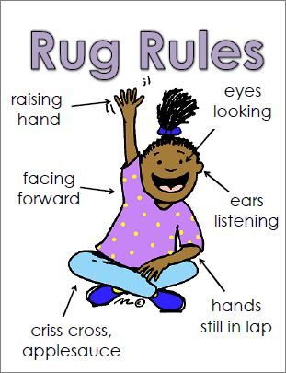
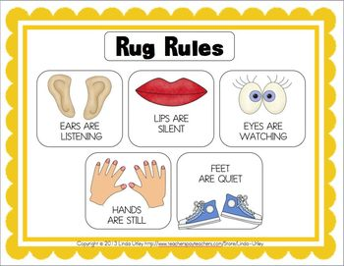
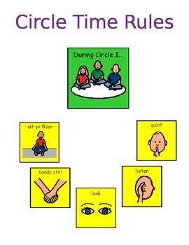

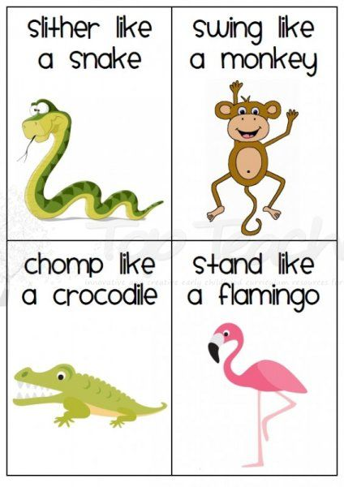
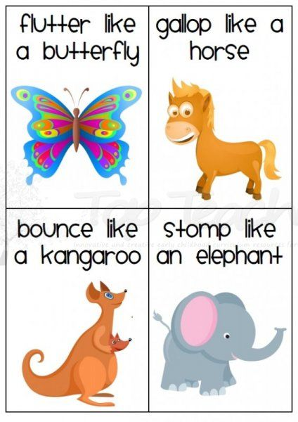
Helping Young Children Understand and Identify Feelings

In order for children to gain control of their behavior when they are experience strong emotions, they first must be able to identify their feelings. Adults can assist children in learning how to label emotions and give them ways to express feelings and solve problems. When young children do not have the words needed to express their feelings, they rely on actions. Aggressive behaviors such as hitting, kicking or biting are often a result of not being able to effectively express their emotions or needs. If children have not learned ways to express emotion and/or how to gain self-control, their feelings can become overwhelming and contribute to inappropriate choices or actions to get their needs met.

It is important to help young children develop vocabulary to describe various feelings. Teaching children words to label emotions is the first step in helping them learn self-control. At the start of the year, teachers can talk with children about their feelings and provide strategies for children to express them and appropriate ways to request assistance to solve problems. Teachers can brainstorm with children appropriate ways to express and deal with feelings, and they can also share these strategies with families.

In this module you will find some visuals to support children in using words to label their feelings. The feeling wheel and coping wheel may be useful tools at home as well as in school to help children learn how to appropriately deal with their emotions. It’s important for teachers to acknowledge and reinforce when they observe children using words to express their feelings, or when they ask for assistance to solve problems or deal with frustration or anger.

When children have a difficult time calming down, they may need assistance. Some children will need to be redirected to appropriate activities to work out their feelings before they are able to engage in problem solving strategies (e.g., if angry, pound playdough; if sad, go to a quiet place; use movement such as stomping or throwing bean bags).

The following activities have been compiled to support educators in assisting children in expressing emotions, calming down, and solving problem throughout the school year.

Feeling Good: Use an emotions chart to have children identify/point to the emotions that make them feel good. Encourage them to name those emotions and create stories explaining why they feel that way.

Attendance/Check in Board: Create a check-in board where children place their name or photo and a “feeling picture.” Or they could draw a face to express how they feel. Follow up by having a conversation with children about how they are feeling. As the day progresses you may want to ask children if their feelings have changed and why.

How are you Feeling? Ask children to show how they look when happy, sad, angry, or frustrated. Discuss how faces and bodies express how people are feeling. For example, people who are angry will frown or scowl; sometimes the way people stand gives clues about how they are feeling (e.g., folded arms or arms reaching out). Children could make faces in a mirror. Or children could pair up and one child makes and labels a facial expression while the other acts as the mirror.

Feeling Wheel - Pictures can help children find an appropriate way to express how they are feeling. When a child has a difficult time using words to express feelings, the “feeling wheel” can be used to help the child label his/her emotions.

Emotions collages - Cut pictures out of magazines, looking for pictures of a range of emotions. Teachers can encourage children to label the emotions illustrated. Teachers can write children’s words with their permission.

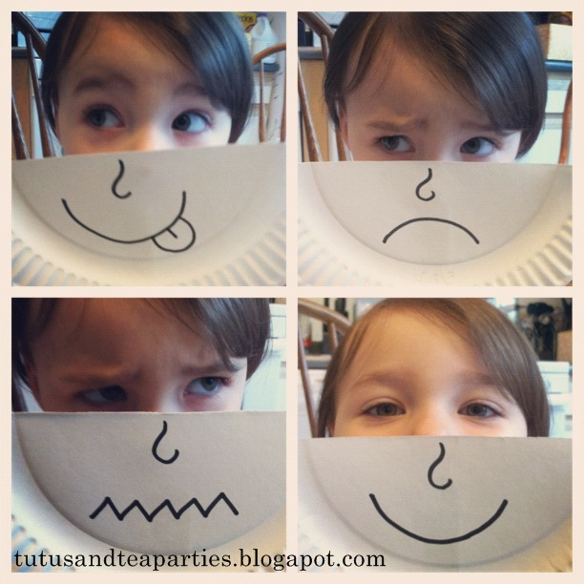
Paper Plate Emotions Pockets: Draw or attach a feeling face onto half a paper plate pockets. Staple the two halves of the plate together to make a pocket. Cut out pictures and place the pictures in pocket. Use the paper plate pockets to encourage oral story telling. Have children talk about what make them feel sad, angry, happy or puzzled.

Feelings Dice: Show pictures and discuss the emotions they invoke. Take photos of children demonstrating emotions. Print out the photos of children’s faces and place them on large six-sided cubes as dice. Children then toss the dice, identify the feeling, and remember a time they felt that way. As an alternative, ask children to demonstrate how they look when they express that emotion.

Puppets: Children use puppets to discuss feelings. Role play classroom situations using puppets. Discuss the feelings of both puppets. Discuss how problem-solving skills can be used to help the puppets solve the problem.

Bingo Game: Use a “feelings bingo game” to identify feelings.

Feelings Memory Game: Match pairs of pictures of various emotions.

Paper Plate Feelings Stick Puppets: Draw faces representing various emotions on small paper plates and tape them on craft stick to make puppets. These can be used to sing songs about feelings or to show how a character in a story is feeling.

Sunny Thoughts: Wrap a tissue box in yellow paper and label it SUNNY THOUGHTS. Leave the box and some slips of paper on a table. Tell children that during the week they can leave notes or drawings to make the class feel good in the box. These notes can be compliments to individuals, positive comments about what happened during the week, or reflections on what was learned in school. Teachers should model this for the group.

Charades: Start the game by saying, “To play the game, you must act out an emotion using your body and face.” Challenge children to guess the emotion being portrayed. Have some children choose an emotion to act out.

How would you feel? Ask children to talk about how they would feel in each of the situations below, or have them demonstrate their feelings by making faces. You could take photos of the children acting out feelings, and the photos could be printed out and laminated and used to create games such as “concentration” (finding two photos that match); matching a photo to a printed emotion word; identifying a photo that illustrates a specified emotion.
- Amy’s new markers are missing from her cubby.
- Anthony opened the door and saw a cake, and everyone yelled, “Happy Birthday!”
- Juan’s best friend is moving far away.
- Keisha’s mom made cookies to bring to her grandmother. Keisha’s mom caught her eating one after she said she could not have them until they got to her grandmother’s house.
- It is your birthday and you got a new toy that you have wanted.
- You lost your mitten.
- You are selected for line leader.
- You think you never going to get a turn being line leader.
- The teacher says it’s your turn on the computer after you have been waiting.
- There is no room for you in dramatic play and your friend is playing there.
- You fell and skinned your knee.
- You’re having a hard time putting the puzzle back together.
- You dropped your ice cream scoop off the cone.
- You spilled your milk.
- You cannot open your yogurt container.
- You made a drawing and your sister rips it up.
- You heard someone say they did not like the shirt you were wearing.
- You asked a child to sit next you and they said no.
- You are going with your friend to the park after school.

Synonyms: Generate a list of feeling words and synonyms and have children illustrate the list with self-portraits, for example:
- Happy = cheerful, joyful, jovial, gleeful, delighted, pleased, glad, or joyous
- Sad = unhappy, sorrowful, glum, gloomy, forlorn, miserable or awful
- Excited = thrilled, inspired, delighted, exhilarated, electrified

Emotions Sorting: Have a “Mystery Bag” with pictures of faces displaying various emotions inside. Have children reach into the bag and choose one of the faces from the bag and make a similar face, identify the emotion, and tell when they felt that way.

Go Fishing: Put emotion faces on cardstock, cut out, and add magnets. Provide a magnetic fishing pole and spread the fish out onto piece of paper for a pond or in the sensory table. Have the children go fishing for a feeling and then describe the emotion. As an alternative, use photos of the children.

Sign Language Feelings Words: Teach children sign language for different feelings. Use sign language when singing songs such as “If You’re Happy and You Know It.”

Ways to help children cope with anger or frustration

Physical Activity: Do something physical can help children focus on something else and help them calm down (e.g., use animal movement cards).

Mad Dance: Do something with your body such as the “Mad Dance” (stomping feet)

Manipulative Materials: Squish a ball, playdough, clay or Theraputty.

Talk about Feelings: Use visuals to help child talk about emotions, such as an “angry thermometer,” puppets, or an emotions poster. Talking can help work through anger and solve the problem in a positive way. If they do not want to talk with adults, use puppets or stuffed animals.

Make up an “Anger Song:” Help children make up words to a song or poem to express what they are feeling.

Sharing ideas about how others handle anger: Help children collect ideas from others on how to cope with anger. Help children decide which ones to try (e.g., take a fast walk, squeeze playdough, yell into a pillow).

Anger Management Wheel: Make an Anger Management Wheel with visuals of safe alternatives to use when angry (e.g., take a deep breath; count to 10; pound playdough; listen to music, go to quiet corner, etc.)

Relaxation Strategies: Teach children to relax with activities such as yoga, deep breathing, or finger painting. Teach “Think Before You ACT” – clench fist and make a mad face; relax all your muscles; take a deep breath, and count to 10. Encourage children to use words to describe how they are feeling about what happened.

Mad Representations: Scribble as hard as you can on scrap of paper and throw the paper away as if you are throwing the anger away.

Angry Art: Use the color red to draw or paint a picture of something that make you mad.

Mad-O-Meter - Give children a pre-made thermometer using template from CESEL website. Give them shades of red ranging from dark red to pink to white. White represents calm, middle can be pink, and dark red angry. Explain the progression from calm to mad. When you feel mad you can move the clothespin down as you use your self-control techniques.

Teaching Self-Control and Anger Management
Teach children these steps for problem solving:
- THINK about what happened.
- THINK of how your body feels (it will be necessary to review several basic feeling words with young children or use feeling chart)
- RECOGNIZE the feeling
- SAY: “I feel_____________.”

Dictate a Story: Encourage child to dictate a story about what has made him/her angry and have the adult read it back. The child can then crumple up the paper and throw it away.

What is your body telling you? Explain that you want to talk about feelings and how we can get messages from the way our bodies behave. These messages tell us how we feel about experiences.
- Happy – Smile, laugh, relaxed muscles, calm breathing
- Sad – Frown, cry, crossed arms, move slowly
- Angry – Red face, frown, tense muscles, fast breathing
- Scared – Big open eyes, rapid heartbeat, stand still, and quiet

Ask children to provide examples of their own feelings (e.g., “Can you tell me about a time you felt frustrated, excited, or impatient?”)

Ideas for discussion during role playing: Use these questions to help children think about appropriate choices and behaviors in the role playing scenarios described above:
- When you have comfortable feelings, how might you show them to other people? (e.g., smile, laugh, hug, act friendly)
- How do you think other people feel when you show them your comfortable feelings?
- When you have uncomfortable feelings, how might you show them to other people? (e.g., yell, frown, cry, or fold arms).
- How do you think other people feel when we show our uncomfortable feelings?
- How do you think expressing feelings might help us all get along better with one another? (Explain that understanding each other’s feelings and our differences helps us to communicate better, resolve conflicts, and share in each other’s excitement or happiness).

Teaching self-control:
- SKILL – Knowing your feelings
- SKILL – Dealing with feelings (sadness, anger, or frustration)
- SKILL – Dealing with wanting something you cannot have

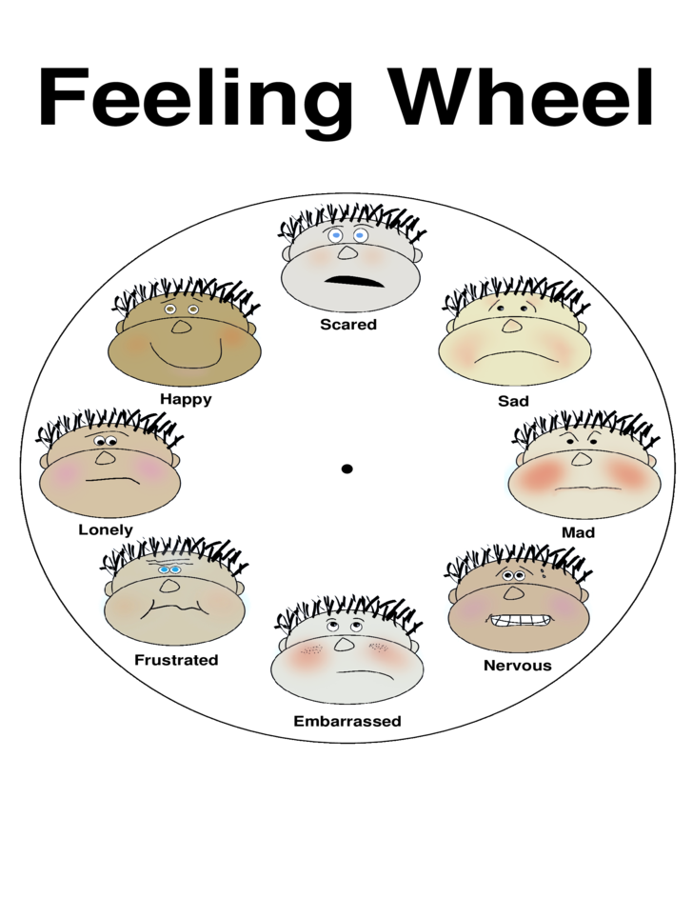

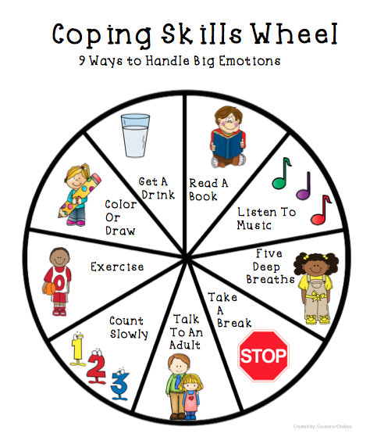

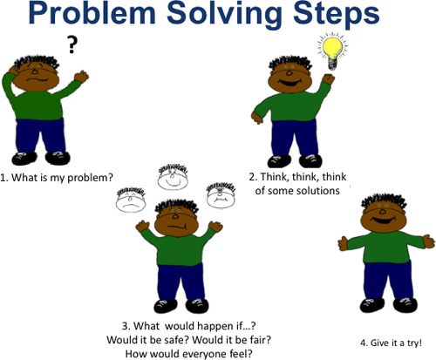

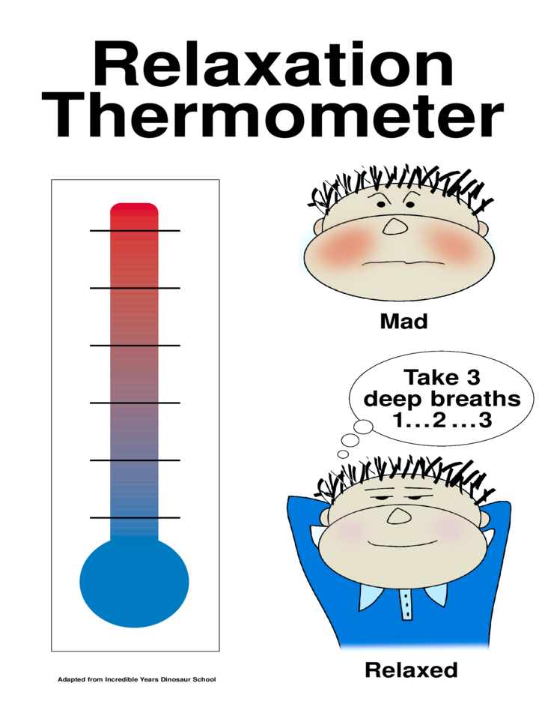

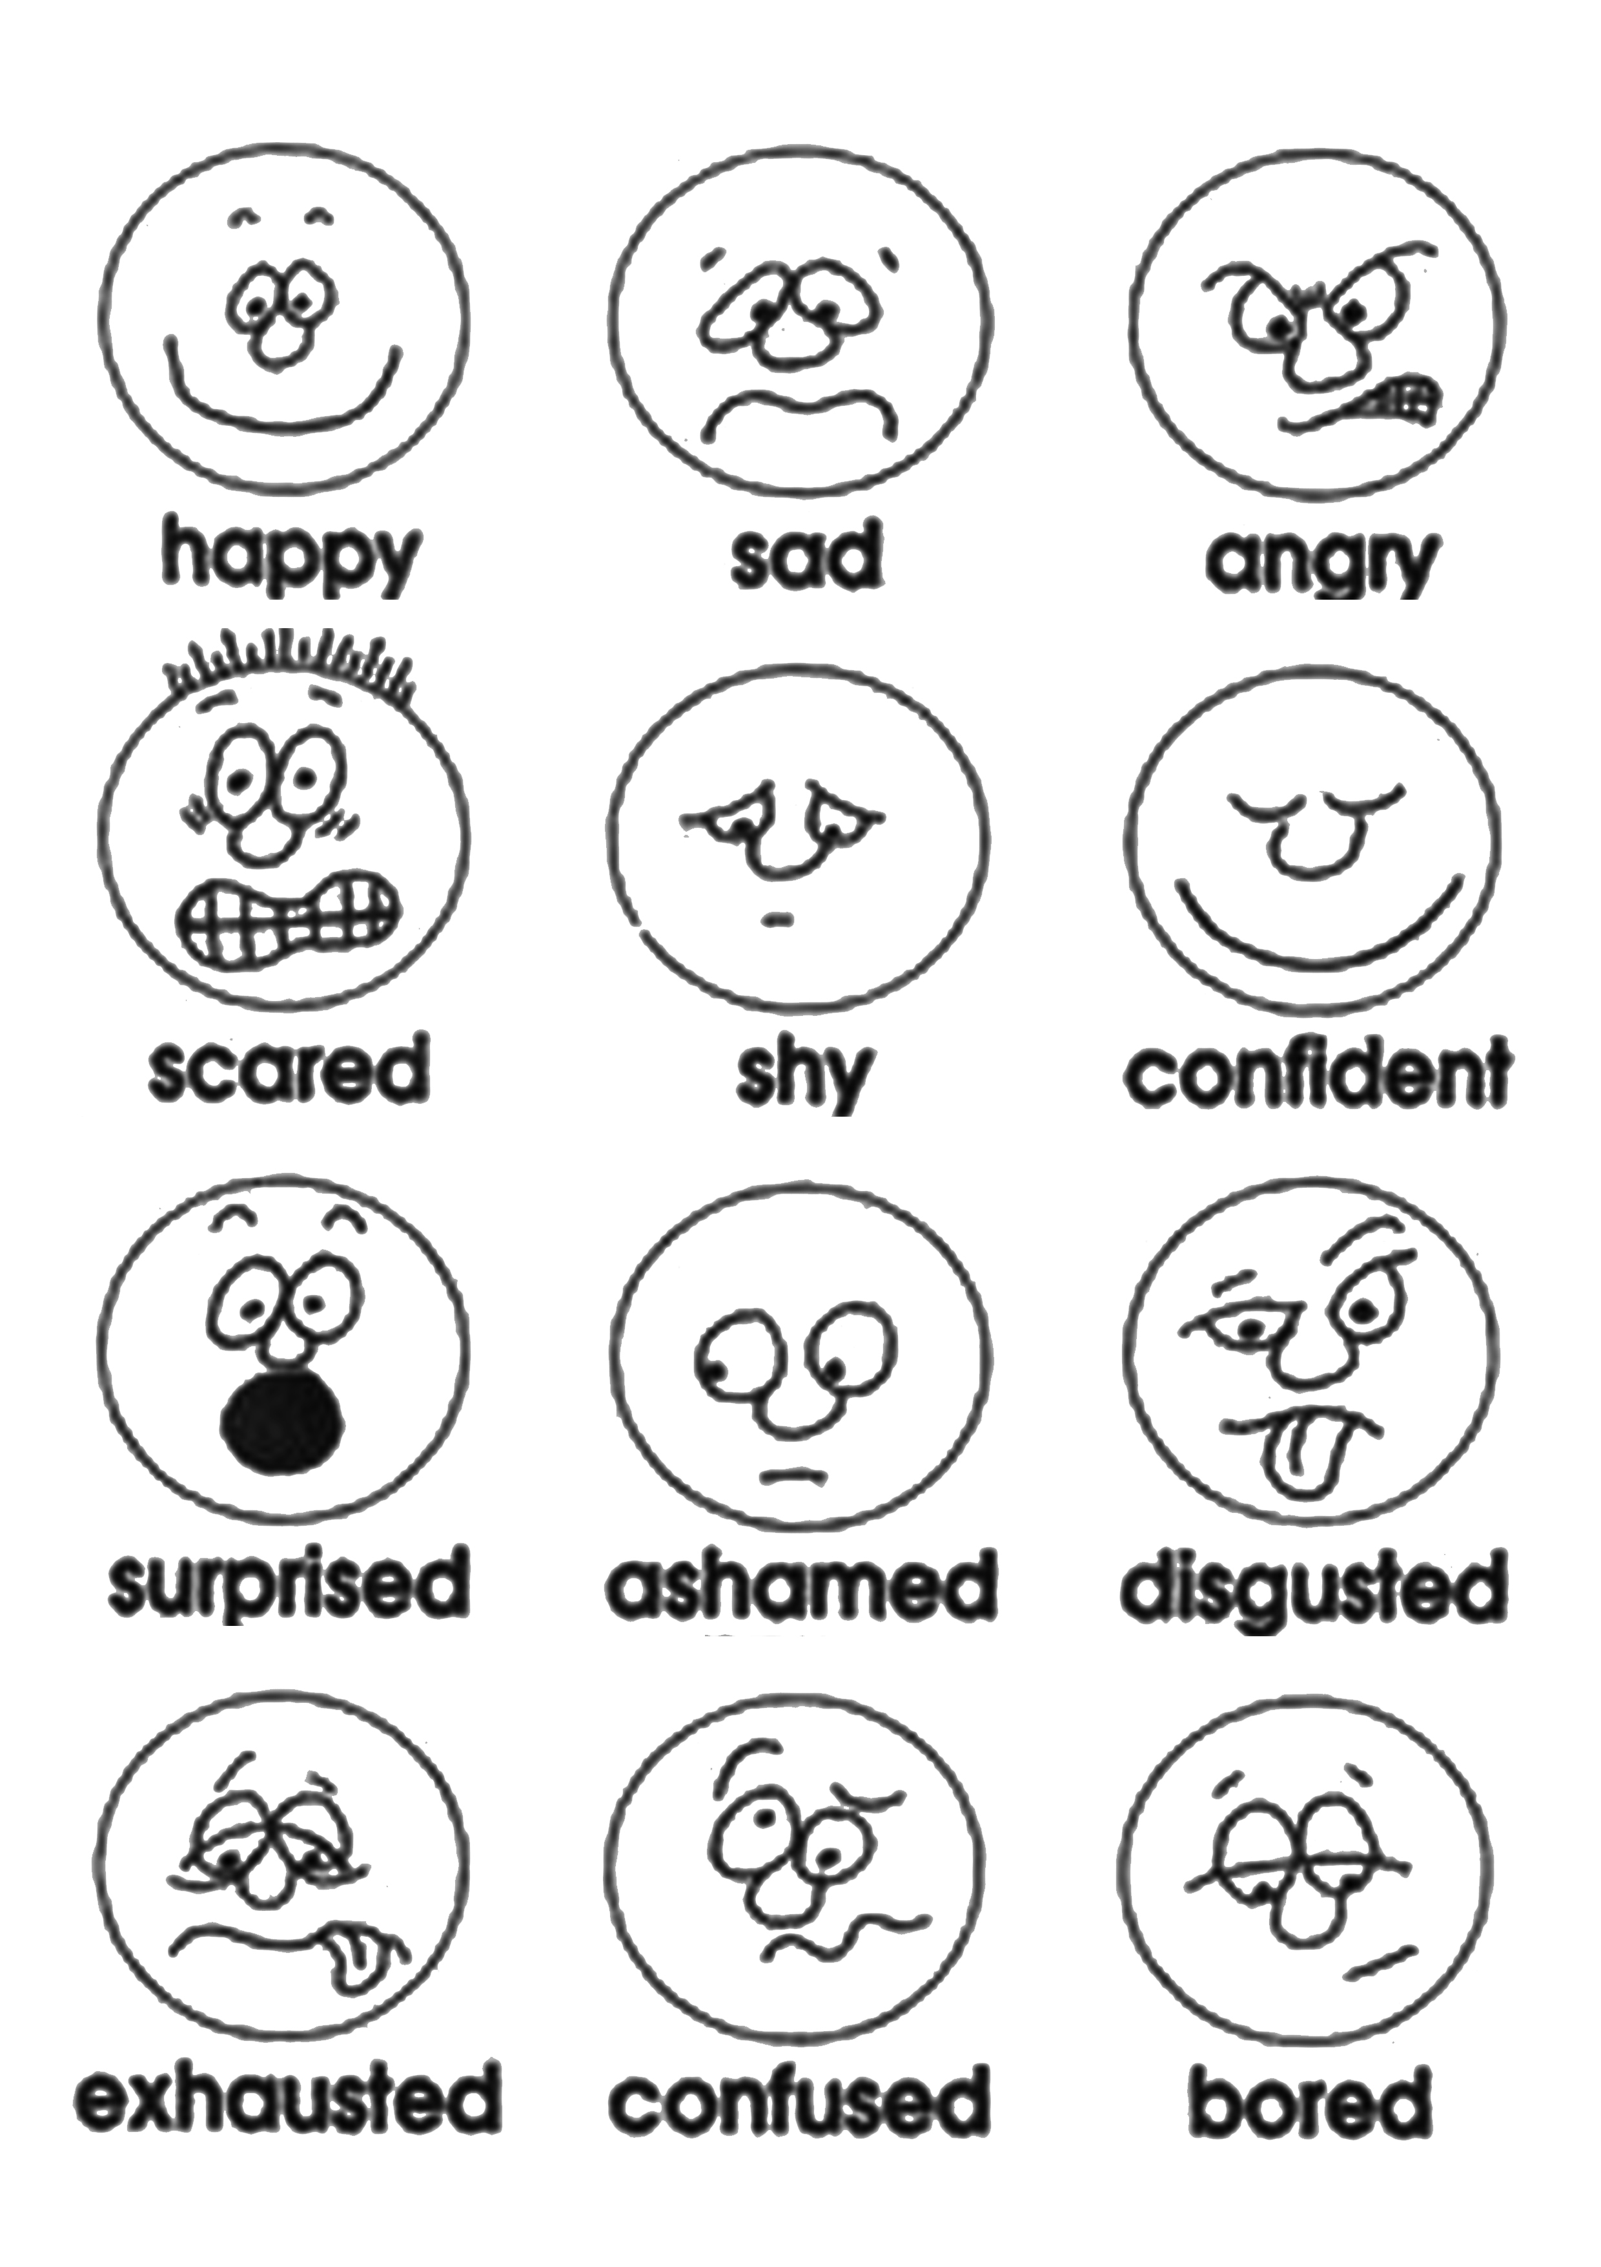
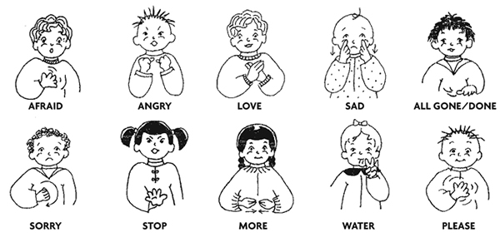

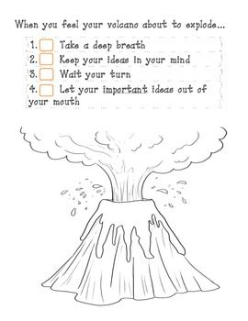
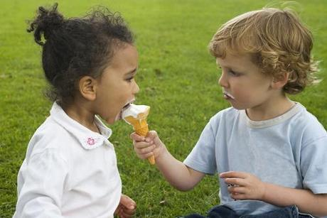
Pictures to Discuss Feelings

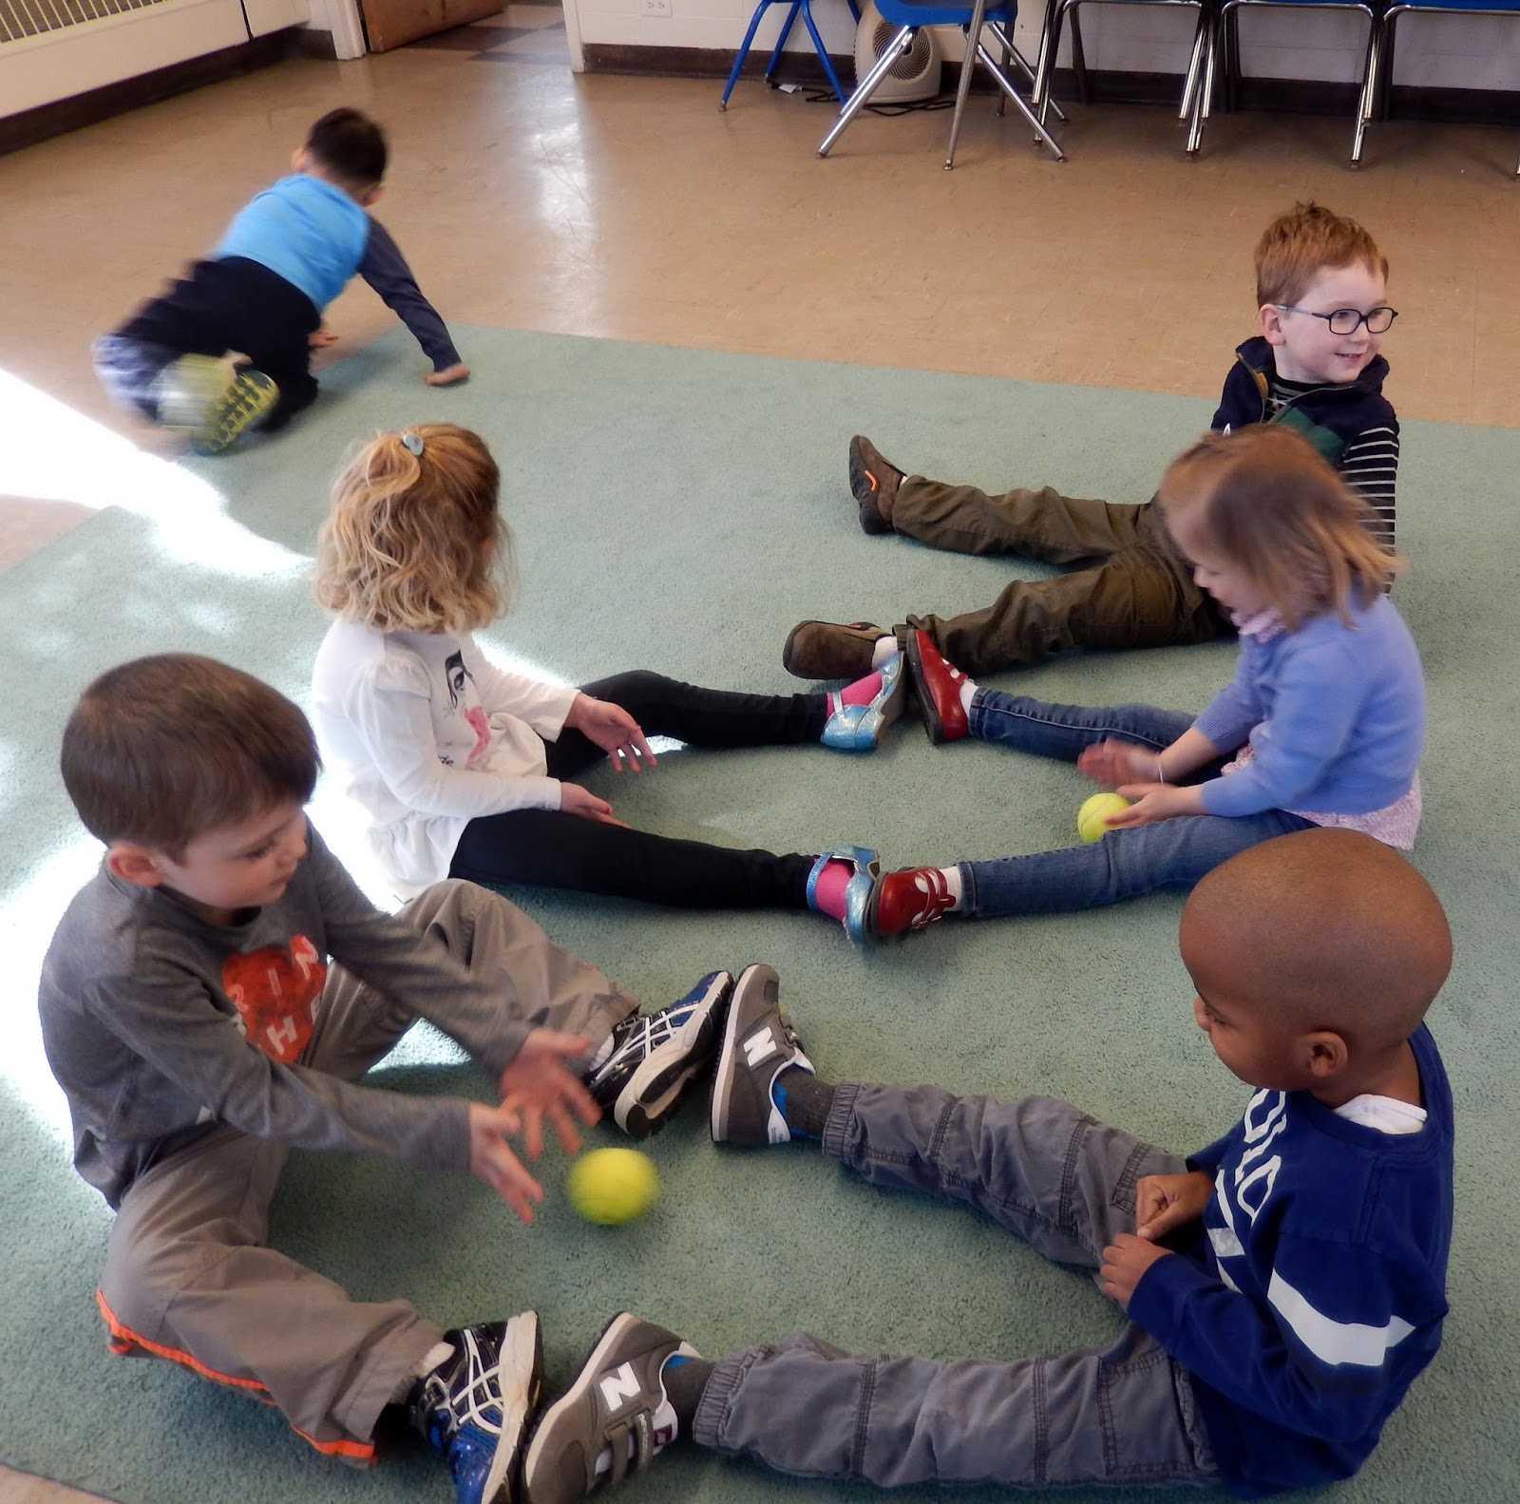

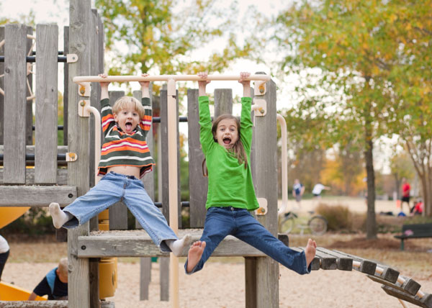

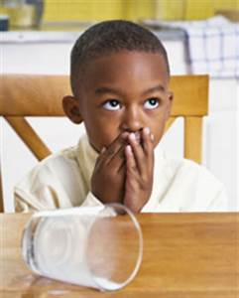

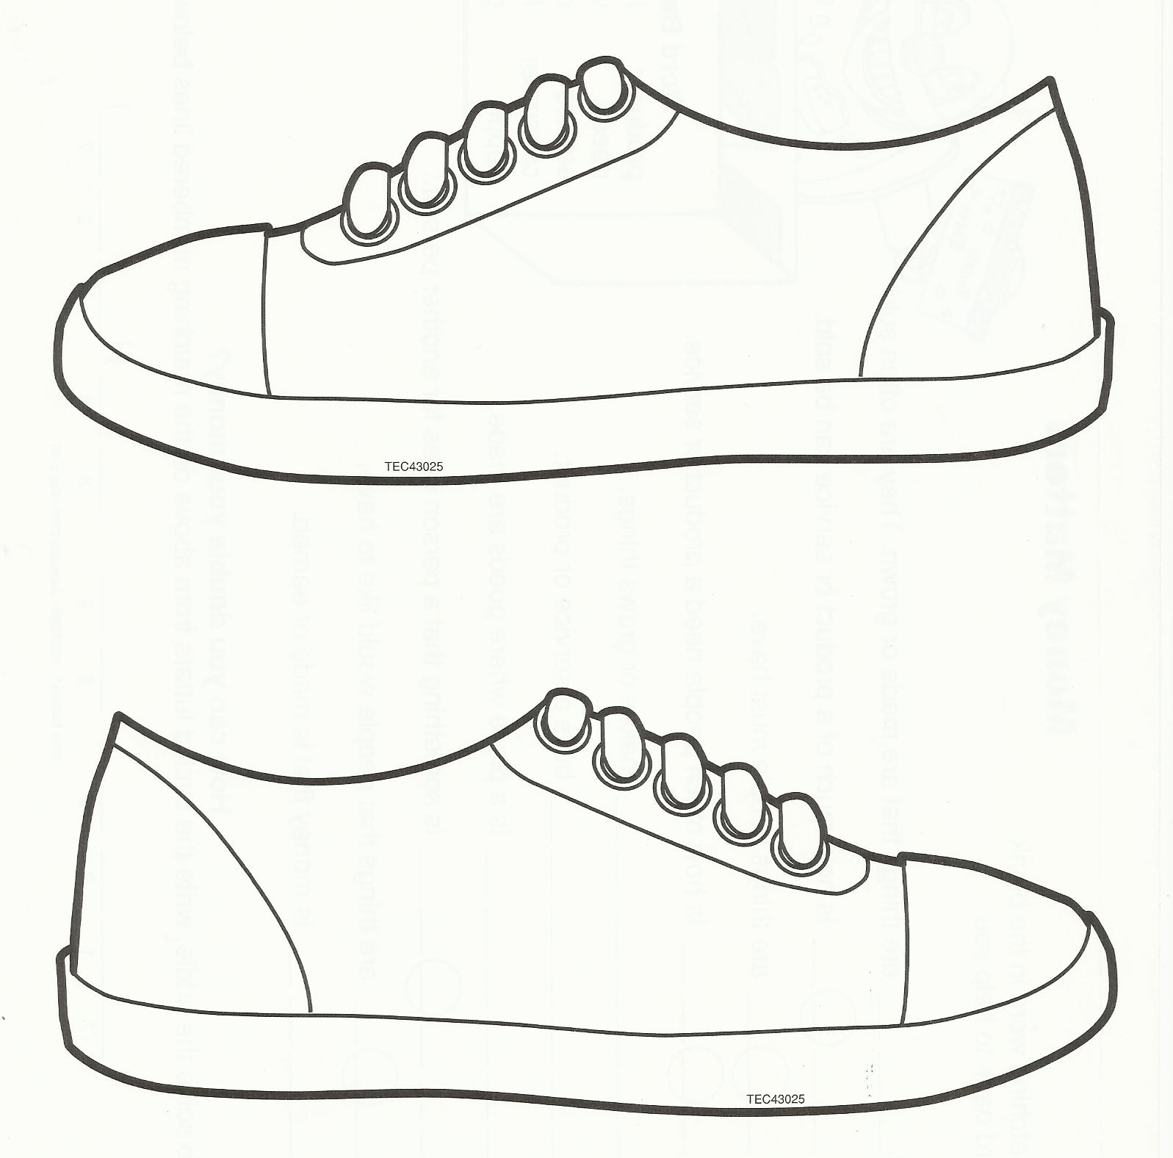



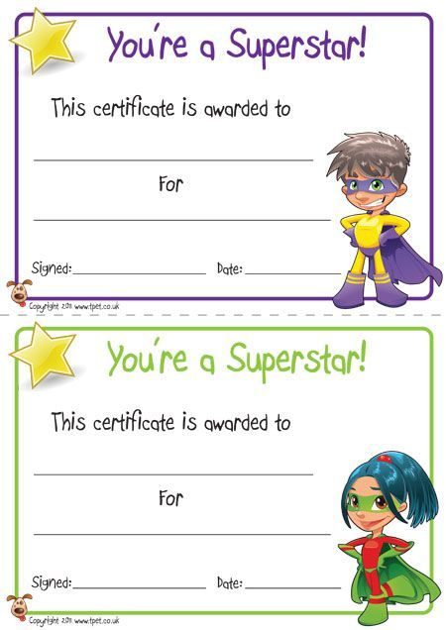
A Story of Units Lesson 4 Fluency Template PK-1
I Have 2 Chant
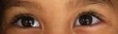 I have 2.
1, 2.
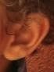 I have 2.
1, 2.
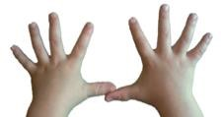 I have 2.
1, 2.
 I have 2.
1, 2.
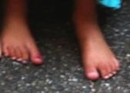 I have 2.
1, 2.
Yahoo! And so do you!

Eureka Math and licensed by Great Minds. © 2015 Great Minds. eureka math.org

Template – Kissing Hand Stationary

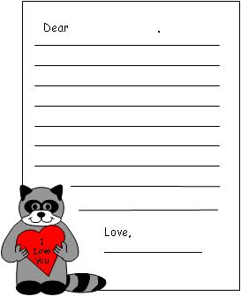

From: www.makinglearningfun.com

Template

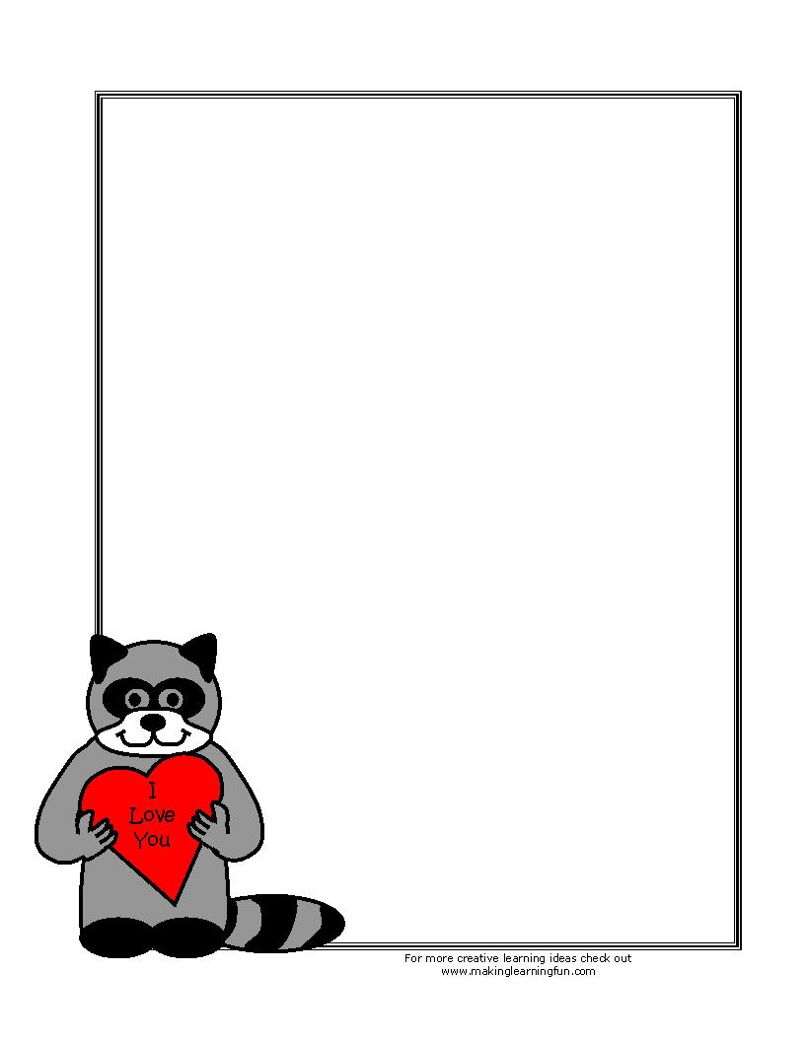
Htpp://www.makinglearningfun.com/t_emplate.asp?t http://makingle.../Activities/KissingHandStationary/KissHand-C-NoLines.gif
Kissing Hand - Raccoon Puzzle

My First Day Activity – PBS, Daniel Tiger


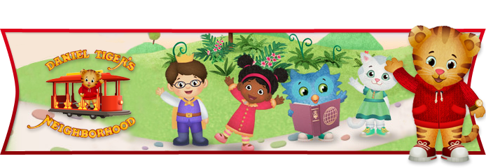

Young children often feel mixed about starting a new care situation. Their feelings are often mixed: excited about “new things” and scared about being away from the familiar adults that usually take care of them.

Learning Goals Children are working on:
- Practice with expressing feelings
- Encourage memory skills
- Practice listening skills

Materials:
- None

Directions:
- Talk with children about how Daniel felt about starting school; about how his parents and teacher helped him.
- Ask the children if they can remember their first day of school:
- Do they remember the other children who were there?
- Do they remember what they had for snack?
- Do they remember if they have brought along a favorite toy or blanket?
- Did they discover a favorite toy they liked to play with that day?
- Do they remember when their mom or dad came to pick them up?
- Do they remember what they did when they went home?

The accuracy of their recall isn’t what’s important. What is important is that they think about, express, and listen to each other’s feelings about starting school. You might also want to share some of your memories about the first time each of them started school.

http://www.pbskids.org/daniel
© The Fred Rogers Company

Greeting Songs

The More We Get Together
The more we get together, together, together
The more we get together the happier we’ll be
Cause your friends are my friends
And my friends are your friends
The more we get together the happier we’ll be.

Little Yellow Bird
Good morning little yellow bird, yellow bird, yellow bird,
Good morning little yellow bird, who are you?
Child states name ___________________________ (while singing the song, pass a cut-out of a yellow bird or stuffed bird around the circle for each child to hold when it is their turn).

Hello Neighbor (wave)
What do you say? (shake hands)
It’s going to be a beautiful day!
So, clap your hands
And stomp your feet
Jump up and down
And have a seat!

If You’re Wearing Red Today
If you’re wearing red today,
Red today, red today.
If you’re wearing red today,
Stand up and shout “Hooray”!
(repeat the song and change the color)

We Welcome You
We welcome you to school today
School today, school today
We welcome you to school today
Please come and play.

We’re glad to have you here today.
Here today, here today
We’re glad to have you here today
Yes, it’s a special day.

Hello Welcome Song
Hello, how are you?
Hello, how are you?
Hello, how are you?
How are you today?

Good Morning Song
Good morning to you.
Good morning, good morning.
And how do you do?

Hello How Are You
Hello, how are you?
Hello, how are you?
Hello, how are you?
Hello, how are you, how are you today?

Turn to your neighbor and shake their and.
Turn to your neighbor and shake their hand.
Turn to your neighbor and shake their hand.

“How are you today, today, how are you today?”
“I’m fine” (point hands to yourself).
“How about you ‘child’s name’?” (wait for answer)
(Teacher open hands and point to child).
“I’m fine”, “How about you ‘child’s name’?” (wait for answer)
“I’m fine”, “How about you ‘child’s name’?” (wait for answer)
(After saying all the children’s names)

How are you today, today, how are you today?
Hello, how are you, hello, how are you, hello, how are you , how are you today, today, how are you today?”

I Like to Go to School
I like to go to school.
I like to go to school.
Heigh-ho-the-derry-oh,
I like to go to school.

I like to sing new songs.
I like to sing new songs.
Heigh-ho-the-derry-oh,
I like to sing new songs.

I like to play with friends.
I like to play with friends.
Heigh-ho-the-derry-oh,
I like to play with friends.

Circle Time Song
Circle time, circle time,
Let’s all gather near.
Circle time, circle time,
Everyone come and hear.

Circle time, circle time,
Let’s all gather round.
Circle time, circle time,
Everyone come and sit down,
Everyone come and sit down.

I Wiggle (Wiggle the body parts as they are mentioned).
I wiggle my fingers,
I wiggle my toes,
I wiggle my nose,
I wiggle my shoulders,
Now no more wiggles are left in me,
So, I will sit as still as I can be.

Two Little Feet
Two little feet go stamp, stamp, stamp (stamp feet)
Two little hands go clap, clap, clap (clap hands)
One little boy stands up straight (stand straight)
One little body goes round and round (turn)
One little body sits quietly down (sit)

Two
Two eyes to see the things to do
Two lips to speak clearly the whole day through
Two ears to hear what others say
Two hands to put the toys away.

For Story Time
Sometimes my hands are at my side (hold hands at side)
Then behind my back they hide (put hands behind back)
Sometimes I wiggle my fingers so (wiggle your fingers)
Shake them fast, shake them slow (shake fingers fast and slow)
Sometimes my hands go clap, clap, clap (clap hands)
Then I rest them in my lap
Now they’re quiet as can be. (sit down and rest hands in lap)

Have a Seat
Use this rhyme to get children seated and prepare them for a new activity.
Everybody have a seat, have a seat, have a seat.
Everybody have a seat on the floor.
Not on the ceiling.
Not on the door.
Everybody have a seat on the floor.
Everybody have a seat, have a seat, have a seat.
Everybody have a seat on your chair.
Not on the window.
Not in the air.
Everybody have a seat on your chair.

Line-Up Cadence
Clap thighs and stamp feet to the rhythm of this chant as children repeat each line.
Lining up is easy to do.
When you take care of only you.
Feet together, hands by sides.
We’ve got spirit, we’ve got pride.
Sound off, 1, 2.
Hit it again, 3, 4.
Ready now? 1, 2, 3, 4 – out the door!

We Are Walking
We are walking, we are walking
Here we go
Nice and slow.

Let’s Clean Up
Let’s clean up today
Let’s clean up today
We’ve had our fun
Our day is done.
So, let’s clean up today.

It’s Time to Clean Up
Are you helping
Are you helping
Pick up toys,
Pick up toys,
Let us all be helpers,
Let us all be helpers,
Girls and boys, girls and boys.

Clean-Up Song
Clean-up, clean-up
Everybody get some toys.
Clean-up, clean-up
All the little girls and boys.
Clean-up, clean-up
Everybody do your share.
Clean-up, clean-up
Everybody, everywhere.

Dismissal Song
Good bye girls,
Good bye boys,
Good bye girls and boys
It’s been a mighty fine day.

Name Songs

Higgelty, Wiggelty Bumblebee.

Higgelty, wiggelty bumblebee.
Who can say their name for me? (child says name)

Here Today Song
(Child’s name)’s here today, shout hurray!
(Child’s name)’s here today, shout hurray!
(Child’s name)’s here today, she/he will learn and laugh and play.
Oh, (child’s name)’s here today, shout hurray!

Where Is _________________?
Where Is (Child’s Name)?
Here I am
Here I am
We’re glad to see you,
We’re glad to see you,
At school today,
At school today.

Good Morning Jacob
How are you?
Shake hands with Garrett next to you.
(Continue around the circle, include teachers too.)

It’s Nice to See _____________ Here.
It’s nice to see (child’s name) here
It’s nice to see (child’s name) here
It’s nice to see (child’s name) here
It’s nice to see (child’s name) here
How are you today?

Good Morning to You
Good morning to you,
Good morning to you,
Good morning dear friends….
It’s nice to see you!
Good morning … (child’s name)
Good morning … (child’s name)

New Child Welcome (Teacher and children sing to welcome a new child. Sing to the tune of “Where is Thumbkin”)
Where is (new child’s name)
Where is (new child’s name)

There he is (palm up in the direction of the child)
There he is (palm up in the direction of the child)

How are you today (thumb up, fingers closed)
How are you today (thumb up, fingers closed)

Come and play (hands inviting child to play)
Come and play (hands inviting child to play).

Come to School
(Child’s name) came to school today, school today, school today
(Child’s name) came to school today.
He’s/she’s our friend.

Mary’s Here Today
Mary’s here today. Mary’s here today.
We’ll all clap our hands and say,
Mary’s here today,

Where is Linda?
In morning song or for circle time.
Teacher: Where is Linda? Where is Linda?
Linda: Here I am, here I am.
Teacher: How are you this morning?
Linda: Very well, I thank you.
Teacher: Hop away, Hop away.
(Linda hops away)

Songs About Me

I’m Just Happy to Be Me
I’m Just Happy to Be Me
I think you’ll agree.
I’m very special all by myself.
One of a kind, and I don’t mind.
Because I’m just happy to be me.
I’m the best “me” that I can be.

I Am Special
I am special, I am special.
If you look, you will see,
Someone very special, someone very special,
Yes, it’s me,
Yes, it’s me.
(Additional verses: include individual children’s names in subsequent verses)

Body Parts
Head and Shoulders
Touch each body part with both hands and follow the action described.
Head and shoulders, knees and toes.
Knees, knees and toes.
Head and shoulders, knees and toes.
Make your feet go stamp, stamp, stamp.
Nose and elbows, feet and waist.
Feet and waist, feet and waist.
Nose and elbows, feet and waist.
Make your hands go clap, clap, clap.

Hokey Pokey
You put your right hand in,
You put your right hand in,
You put your right hand in,
And shake it all about.
You do the Hokey Pokey, (wiggle)
And you turn yourself about,
That’s what it’s all about.
Continue by putting in all the other parts of the body, and finish with your whole self.

Feelings Songs

If You’re Happy and You Know It

If You’re Angry and You Know It 
If you’re angry and you know it stamp your feet, pound your fists, etc.

I Have Feelings
I have feelings, you do too.
Let’s all sing about a few.

I get “happy”.

I get “sad”



I get “scared”


And, I get “mad”

I have feelings, you do too,

We just sang about a few.

As you sing the song demonstrate the emotion with facial expressions and/or emotions stick puppets.

For additional verses include children’s names in each verse (i.e. John has feelings, you do too. Let’s all sing about a few. John gets happy. John gets sad. John gets scared. And, John gets mad. John has feelings. You do too. We just sang about a few.

I’ve Got That Happy Feeling

I’ve got that happy feeling here in my heart.
Here in my heart, here in my heart.
I’ve got that happy feeling here in my heart.
Here in my heart.


I’ve got that happy feeling here in my feet, etc.

I’ve got that happy feeling here in my hands, etc.
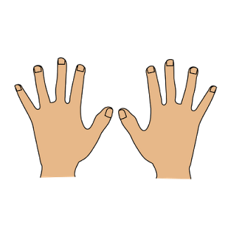

I’ve got that happy feeling all over me, etc.

When I’m Feeling Happy
When I’m feeling happy,
When I’m feeling happy,
Just look at my face and you will see,
The biggest smile there ever can be,
It starts right here
And stretches from ear to ear.

Then comes a giggle.
Followed by a wiggle.
And before you know it, there’s no chance
I can’t stop myself from doing the happy dance.

When Angry Feelings Start to Mount
When angry feelings start to mount,
That’s when I take time to count.
One …. Two …. Three …. Five
Counting helps me settle down,
Counting helps to fade my frown.
Six …. Seven …. Eight … Nine …. Ten

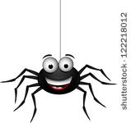

Itsy Bitsy Spider

Sing the Itsy, Bitsy Spider. Now introduce the spider’s neighbors. They include the “Happy Little Spider”, the “Sad Little Spider” “Shy Spider”, “Afraid Spider”, “Silly Spider”, etc. Sing the words and act out the emotion with your face and words.

Friends

Make New Friends
Make new friends, but keep the old
One is silver and the other is gold.

Will You Meet a Friend of Mine?
Friend of mine?
Friend of mine?
Will you meet a friend of mine?
This is my friend ____________________ (child’s name).

Let’s Find a Friend
Oh, let’s find a friend
Heigh-ho-the-derry-oh!
Let’s find a friend!

Pick a child to start in the center.
(______________) find a friend,
(______________) find a friend,
Heigh-ho-the-derry-oh!
(______________) find a friend,

Have the adults stand on the outside to make up the remainder of the circle, so all the children get to be inside. Then sing:
We all found a friend,
We all found a friend,
Heigh-ho-the-derry-oh!
We all found a friend.

If You’re Friendly (Sung to tune of: “If You’re Happy and You Know It”).
If you’re friendly and you know it,
Clap your hands.
If you’re friendly and you know it,
Clap your hands.

If you’re friendly and you know it,
And you really want to show it,
If you’re friendly and you know it,
Clap your hands!

The More We Get Together
The more we get together, together, together
The more we get together, the happier we will be.
For your friends are my friends,
And my friends are your friends,
The more we get together, the happier we will be.

Do You Know This Friend of Mine?
Do You Know This Friend of Mine?
This friend of mine, this friend of mine,
Do you know this friend of mine?
At (your school’s name) today.

Will You Be a Friend of Mine?
Will You Be a Friend of Mine?
Friend of mine, friend of mine,
Will you be a friend of mine?
And (choose an action) around with me.

Books to Support Social-Emotional Learning
Compiled by Sandra Putnam-Franklin
[Books are listed in alphabetical order by author]

General books about feelings (various emotions):
See How I Feel by Aigner-Clark, J.
Feelings by Aliki
Happy and Sad, Grouchy and Glad by Allen, C.
Everybody Has Feelings: The Moods of Children by Avery, C.
The Story of My Feelings by Berkner, L.
Happy Hippo, Angry Duck: A Book of Moods by Boynton, S.
Happy, Sad, Jealous, Mad by Browning-Wroe, J.
Double-Dip Feelings: Stories to Help Children Understand Emotions by Cain, B.
The Way I Feel by Cain, J.
Today I Feel Silly, And Other Moods That Make My Day by Curtis, J. L.
Glad Monster, Sad Monster: A Book About Feelings by Emberley, E.
Sometimes I Feel Like a Storm Cloud by Evans, L.
Can You Tell How Someone Feels? by Everly, N.
How Are You Peeling: Foods with Moods by Freymann, S.
Listening to my Body by Garcia, G. (the connections between body sensations and feelings)
The Feelings Box by Gold, R.
Lizzy’s Ups and Downs by Harper, J.
Drawing Together to Learn About Feelings by Heegaard, M.E..
The Great Big Book of Feelings by Hoffman, M.
C is for Curious, an ABC of Feelings by Hubbard, W.
ABC Look at Me by Intrater, R.
What Are You Feeling, Dragon? by Lalgudi, S.
Feelings by Law, F.
I Have Feelings by Leeper, A.
Proud of Our Feelings by Leghorn, L
The Color Monster by Llenas, A.
A Book of Feelings by McCardie, A.
F is For Feelings by Millar, G.
ABC Book of Feelings by Moddy, M.
I Feel Happy, and Sad, and Angry, and Glad by Murphy, M.
The Feelings Book by Parr, T.
Feelings and Emotions/Sentimientos by Petelinsek, K.
Some Days, Other Days by Petersen, P.J.
Feelings Inside You and Outside Too by Polland, B.
So Many Feelings: Sign Language for Feelings and Emotions by Prochovnic, D.B.
Yo! Yes by Raschka, C.
Lots of Feelings by Rotner, S.
Visiting Feelings by Rubenstein, L.
All Kinds of Feelings by Safran, S
How Do I Feel? by Simon, N.
How Do You Feel? by Stanley, M.
My Many Colored Days by Dr. Seuss
Sometimes I’m a Bombaloo by Vail, R.
The Pigeon Has Feelings Too by Willems, M.
In My Heart: A Book about Feelings by Witek, J.

Angry or Mad Feelings:
When I’m Angry by Aaron, J.
Hands Are Not for Hitting by Agassi, M.
When Sophie Gets Angry – Really Angry by Bang, M.
Feeling Angry by Berry, J.W.
Let’s Talk About Feeling Angry by Berry, J.
Everybody Feels Angry by Bingham, J.
The Chocolate Covered Cookie Tantrum by Blumenthal, D.
Bootsie Barker Bites by Bottner, B.
Happy, Sad, Jealous, Mad by Browning-Wroe, J.
When You’re Mad and You Know It by Crary, E.
I’m Mad (Dealing with Feelings) by Crary, E.
I’m Furious (Dealing with Feelings) by Crary, E.
Llama Llama Mad at Mama by Dewdney, A.
When Emily Woke Up Angry by Duncan, R.
Feeling Angry by Frost, H.
How Are You Peeling? Foods with Moods by Freyman, S.
When Sophie Gets Angry – Really, Really Angry by Garrett, M.
I Hate Everything: A Book About Feeling Angry by Graves, S.
That Makes Me So Mad! by Griffith, D.
Lily’s Purple Plastic Purse by Henkes, K.
Dinah’s Mad, Bad Wishes by Joose, B.
That Makes Me Mad! by Kroll, S.
Andrew’s Angry Words by Lachner, D.
How I Feel Frustrated by Leonard, M.
How I Feel Angry by Leonard, M.
How I Feel Proud by Leonard, M.
I Was So Mad by Mayer, M.
Cool Down and Work Through Anger by Meiners, C.
Mad Isn’t Bad: A Child’s Book About Anger by Michaelene, M.
Angry Is… (Know Your Emotions) by Miller, C.C.
When I’m Feeling Angry by Moroney, T.
Goldie is Mad by Palatini, M.
The Temper Tantrum Book by Preston, E.M.
The Rain Came Down by Shannon, D.
I Was So Mad! by Simon, N.
When I Feel Angry by Spelman, C.M.
Sometimes I’m a Bombaloo by Vail , R.
Alexander and the Terrible, Horrible, No Good, Very Bad Day by Viorst, J.
The Pigeon Has Feelings, Too by Willems, Mo

Happy Feelings
What Makes Me Happy? by Anholt, C. & Anholt, L.
“What Went Right Today?” by Buzick, J.
If You’re Happy and You Know it! by Cabrera, J.
Amadeus is Happy by Cantillon, E.
There's a Big, Beautiful World Out There! by Carlson, N.
Smile a Lot! by Carlson, N.
When You’re Happy and You Know It by Crary, E.
I’m Excited by Crary, E.
If You’re Happy and You Know it! by Carter, D.
Mr. Happy by Hargreaves, R.
Peekaboo Morning by Isadora, R.
When I Feel Happy by Leonard, M.
1,400 Things for Kids to Be Happy About: The Happy Book by Kipfer, B.A.
I Am Happy by Light, S.
Have You Filled a Bucket Today? A Guide to Daily Happiness for Kids by McCloud, C.
The Feel Good Book by Parr, T.
Feeling Happy by Weiss, E.
Susan Laughs by Willis, J.

Sadness:
When Sophie’s Feelings are Really, Really Hurt by Bang, M.
Let’s Talk About Feeling Sad by Berry, J.W.
Franklin’s Bad Day by Bourgeois, P.
The Very Lonely Firefly by Carle, E.
The Boy Who Didn’t Want to Be Sad by Goldblatt, R.
I’m Not Happy: A Book About Feeling Sad by Graves, S.
Yesterday I Had the Blues by Frame, J.A.
Emotions: Feeling Sad by Frost, H.
Cheer Up, Mouse by Henry, J.
On Monday When It Rained by Kachenmeister, C.
How I Feel Sad by Leonard, M.
Hurty Feelings by Lester , H.
When I’m Feeling Sad by Moroney, T.
Sometimes I Feel Awful by Prestine, J.S.
Michael Rosen’s Sad Book by Rosen, M.
Sad Is… (Know Your Emotions) by Salas, L.
I Am Not a Crybaby by Simon, N.
When I Feel Sad by Spelman, C.M.
Spinky Sulks by Steig, W.
Knuffle Bunny by Willems, M.

Scared or Worried Feelings (Fear/Anxiety)
Brave Martha by Apple, M.
Let’s Talk About Feeling Afraid by Berry, J.
Franklin in The Dark by Bourgeois, P.
Wilma Jean the Worry Machine by Cook, J.
I’m Scared (Dealing with Feelings) by Crary, E.
Llama Llama Misses Mama by Dewdney, A.
Tell Me Something Happy Before I Go to Sleep by Dunbar, J.
If You’re Afraid of the Dark, Remember the Night Rainbow by Edens, C.
The Worrywarts by Edwards, P.D.
Ben Over Night by Ellis, S.
I’ll See You When the Moon is Full by Fowler, S.G.
The Wolves in the Walls by Gaiman, N.
Rose Meets Mr. Wintergarten by Graham, B.
Who Feels Scared? A Book About Being Afraid by Graves, S.
But What If? A Book about Feeling Worried by Graves, S.
Don’t Feed the WorryBug by Graves, S.
What Will I Do Without You? by Grindley, S.
I Am Not Going to School Today by Harris, R.
Sheila Rae, the Brave by Henkes, K.
Wemberly Worried by Henkes, K.
A Terrible Thing Happened (for children who have witnessed violence or trauma) by Holmes, M.
Little Rabbit Lost by Horse, H
No Such Thing by Koller, J.F.
What Scares Me; What I Do About It by Kunkel, L.
How I Feel Scared by Leonard, M.
There’s Something There! Three Bedtime Classics by Mayer, M.
There’s an Alligator Under my Bed by Mayer, M.
There's a Nightmare in My Closet by Mayer, M.
Lost by McPhail, D.
When I Feel Afraid by Meiners, C.J.
Have Courage. by Meiners, C.J.
Sam’s First Day (in multiple languages) by Mills, D.
When I’m Feeling Scared by Moroney, T.
Poems About Being Scared by Moses, B.
Scared Is (Know Your Emotions) by Nichols, C.
The Kissing Hand by Penn, A.
I’m Not Scared by Pienkowski, J.
Creepy Things are Scaring Me by Pumphrey, J.
Walter Was Worried by Seeger, L.V.
When I Feel Scared by Spelman, C.M.

Frustration:
Let’s Talk About Feeling Frustrated: A Personal Feelings Book by Berry, J.W.
D.W., Go to Your Room! (an Arthur story) by Brown, M.
The Grouchy Ladybug by Carle, E.
I’m Frustrated (Dealing with Feelings) by Crary, E.
The Pout Pout Fish by Diesen, D.
Sometimes I Feel Like a Storm Cloud by Evans, L.
Mean Soup by Everitt, B.
The Very Frustrated Monster by Green, A.
On Monday When It Rained by Kachenmeister, C.
When I Feel Frustrated by Leonard, M.
Smudge’s Grumpy Day by Miriam Moss
Zach Gets Frustrated by Mulcahy, W.
Smudge’s Grumpy Day by Moss, M.
What I Look Like When I am Confused (Let’s Look at Feeling Series) by Randolph, J.
It’s Not Fair! by Rosenthal, A.K.
No, David! by Shannon, D.
Alexander and the Terrible, Horrible, No Good, Very Bad Day by Viorst, J.
The Three Grumpies by Wight, T.

Other Social-Emotional Topics:

Loss/Death:
I Remember Miss Perry by Brisson, A.
The Memory String by Bunting, E.
The Fall of Freddie the Leaf by Buscaglia, L.
You Hold Me and I’ll Hold You by Carson, J.
Blow Me a Kiss, Miss Lilly by Carlstrom, N.W.
Jim’s Dog Muffin by Cohen, M.
Molly’s Rosebush by Cohn, J.
Grandpa’s Slide Show by Gould, D.
When Someone Dies by Greenlee, S.
The Goodbye Boat by Joslin, M.
Lifetimes: A Beautiful Way to Explain Death to Children by Mellonie, B.
I Remember by Moore-Mallinos, J.
Emma Says Goodbye: A Child’s Guide to Bereavement by Nystrom, C.
The Tip at the End of the Street by Riddle, T.
When A Pet Dies by Rogers, F.
I Wish I Could Hold Your Hand by Palmer, P.
The Saddest Time by Simon, N.
Saying Goodbye to Grandma by Spero, M.H.
Water Bugs and Dragonflies: Explaining Death to Young Children by Stickney, D.
Saying Goodbye to Grandma by Thomas, J.R.
I Miss You: A First Look at Death by Thomas, P.
The Tenth Good Thing About Barney by Viorst, J.

Self-Awareness/Confidence
Happy to Be Me! A Kid Book About Self-Esteem by C. Adams
All by Myself! by Aliki
I Like Myself by Beaumont, K.
Being Me by Broski, J.
Marvelous Me: Inside and Out (All about Me) by Bullard, L.
Pig Enough by Bynum, J.
I Like Me! by Carlson, N.
ABC I Like Me! by Carlson, N.
Hooray for Me! by Charlip, R.
The Featherless Chicken by Chen, C.
I’m Gonna Like Me: Letting Off a Little Self-Esteem by Curtis, J.L.
Ella the Elegant Elephant by Damico, C.
Chocolate Me! by Diggs, T.
Ellison the Elephant by Drachman, E.
The Best Part of Me by Ewald, W.
David’s Drawings by Falwell, C.
Table Chair Bear: A Book in Many Language by Feder, J.
I Can Do It Myself by Fisher, V.
I'm Glad to be Me by Hallinan, P.K.
I Can Do It Myself! (Empowerment Series) by Krensky, S.
I Like Being Me: Poems about kindness, friendship, and making good choices by Lalli, J.
Stand Tall, Molly Lou Melon by Lovell, P.
You and Me by Manna, G.
Feel Confident! A Book About Self-Esteem by Meiners, C.
Just Because I Am by Murphy, L.
What I Like About Me by Nolan, A.Z.
This is My Hair by Parr, T.
It’s Okay to be Different by Parr, T.
I Like Being Me by Parr, T.
I Can Do It All by Pearson, M.E.
The Little Engine That Could by Piper, W.
Why Am I Different? by Simon, N.
All Families are Special by Simon, N.
I Love My Hair! by Tarplay, N.A.
The Skin You Live In by Tyler, M.
I Want Your Moo: A story for children about self-esteem by Weiner, M.B.

Self-Management/Self-Control
Hands are Not for Hitting by Agassi, M.
Think Before You Act: Learning about Self-Discipline and Self-Control by Burch, R.
I Can’t Believe You Said That! Using My Social Filter or Not by Cook, J.
I Just Want to Do It My Way! (About Staying on Task and Asking for Help) by Cook, J.
Tease Monster: A Book About Teasing Vs. Bullying (Building Relationships) by Cook, J.
It’s Hard to be Five: Learning to Work My Control Panel by Curtis, J.L.
On Those Runaway Days by Feigh, A.
Take a Deep Breath: A Book about Being Brave by Graves, S.
The Way I Act by Metzger, S.
Talk and Work it Out (Learning to Get Along by Meiners, C.J.
Cool Down and Work Through Anger by Meiners, C.J.
Respect and Take Care of Things by Meiners, C.J.
Know and Follow Rules by Meiners, C.J.
Voices are Not for Yelling by Verdick, E.
Words are Not for Hurting by Verdick, E.

Social Awareness/Relationships
I Love You Because You’re You by Baker, L.T.
Franklin Says “I Love You.” by Bourgeois
Friends by Carle, E.
What Does It Mean to be Kind? by DiOrio, R.
Empathy Elly-phant: You Can Dance in a Trance with Yellow Polkdot Shoes & Pants by Dunn, C.
Hey, Little Ant by Hoose, P.M.
Just Because: Where Seeing Another Point of View Makes a Better You by Housey, A.
How Little Leigh Made Friends by Huss, S.
Friendship is Like a Seesaw by Innes, S.
Help! A Story of Friendship by Keller, H.
Just My Friend & Me by Mayer, M.
Understand and Care (Learning to Get Along) by Meiners, C.
Join In and Play (Learning to Get Along) by Meiners, C.
Enemy Pie by Munson, D.
How Kind by Murphy, M.
Insides Out (The Empathy Way by Paris, A.
I’m Different You’re Different (The Empathy Way) by Paris, A.
Amelia Bedelia Makes a Friend by Parish, H.
I Love You Just Because by Parr, T.
The Friends Book by Parr, T.
Ordinary Mary’s Extraordinary Deed by Pearson, E.
How Full is Your Bucket? For Kids by Rath, T.
All Kinds of Friends by Simon, N.
Stand in My Shoes: Kids Learning About Empathy by Sornson , B.
When I Care About Others (Way I Feel Books) by Spelman, C.M.
A Sick Day for Amos McGee by Stead, P.C.
Friendship is… 500 Reasons to appreciate Friends by Swerling, L.
Let’s Be Enemies by Udry, J.M.
I’ll Always Love You by Wilhelm, H.
Each Kindness by Woodson, J.
The Hating Book by Zolotow, C.
The Quarreling Book by Zolotow, C.

Respect for Others and for Diversity
Black is Brown is Tan by Adoff, A.
Whoever You Are by Fox, M.
I’m Like You, You’re Like Me by Gainer, C.
We Are Different and Alike: A Book About Diversity by Geisen, C.
I Can Show Respect (Doing the Right Thing) by Guntly, J.D.
A Rainbow of Friends by Hallinan, P.K.
Private Places: A Respect for Others Book by Hardy, C.
Let’s Eat: What Children Eat Around the World by Hollyer, B.
The Colors of Us by Katz, K.
You and Me Together: Moms and Dads and Kids Around the World by Kerley, B.
Accept and Value Each Person: Learning to Get Along by Meiners, C.J.
We All Sing With the Same Voice by Miller, J.P.
It’s Okay to Be Different by Parr, T.
Shades of People by Rotner, S.
All Kinds of Children by Simon, N.
Everyone Matters: A First Look at Respect by Thomas, P.
The Skin I’m In: A First Look at Racism by Thomas, P.
The Skin You Live In by Tyler, M.
Words are Not for Hurting by Verdick, E.

Social/Ethical Responsibility and Problem-solving
Lucy and the Bully by Alexander, C.
Standing Up to Peer Pressure: A Guide to Being True to You by Auer, J.
I Want It by Crary, E.
I’m Lost by Crary, E.
I Can’t Wait by Crary, E.
Horton Hears a Who by Dr. Seuss
I Can Play It Safe by Feigh, A.
But Why Can’t I? A Book About Rules by Graves, S.
I Didn’t Do It. A Book About Telling the Truth by Graves, S.
Not Fair, Won’t Share by Graves, S.
What If Everybody Did That? by Javernik , E.
Never Talk to Strangers by Joyce, I.
I Said No: A Kid’s Guide to Keeping Private Parts Private by King, K.
Share and Take Turns by Meiners, C.
Talk and Work It Out (Learning to Get Along) by Meiners, C.
Know and Follow Rules by Meiners, C.
Be Honest and Tell the Truth by Meiners, C.
Stand Tall! A Book About Integrity by Meiners, C.
We Can Get Along by Payne, L.M.
The Rainbow Fish by Pfister, M.
A Big Fat Enormous Lie by Sharmat, M.
Never Tease a Weasel by Soule, J.C.
Yoko by Wells, R.

Resources from the Center for the Social and Emotional Foundations for Early Learning

Website: http://csefel.vanderbilt.edu/

Solution Kit Card (PRINTED Resources)

The Solution Kit cards can be used to teach children possible solutions to problems. The pictures can be used to teach and assist problem solving during classroom situations.

Problem Solver (PRINTED Resources)

Show pictures of different situations. Ask children to tell you what they think is happening and why they think so. Discuss how the child in pictures may feel and how they might use the problem-solving steps to help them solve their problem.

The Turtle Technique (CSEFEL website)

Teach children the “Turtle Technique” using the picture sequence cards showing the four steps for calming.
- Recognize that you are feeling angry.
- Stop and Think
- Go into shell, take 3 deep breaths. Think calm coping thoughts.
- Come out of shell when calm and think of a solution

Website has story script and Turtle Technique Chart (Some children may want to use the Anger/Relaxation Thermometer to help a child deescalate from anger to relaxation).

Teach children the steps for regaining emotional control:
- First, think about the situation: what happened, what did you do, what is going on?
- Next, realize how you feel: name your emotions, what is going on inside you?
- Lastly, use the information to choose the most appropriate response. (use solution cards to help you find a more appropriate response)

Human Volcano – Handout in resources
- Take a deep breath
- Keep your ideas in your head
- Wait your turn
- Let your important ideas out of your month

Emotional Faces

Scripted Social Stories

I Go to Preschool

I Can Be a Super Friend

I Can Use My Words

I Go to Preschool (on the bus)

What Do We Do in Circle?

I Can Stay Safe

Tucker Turtle Takes Time to Tuck and Think

What do I “get” or “get out of” when I use challenging behavior?
What happens just before the behavior? | BEHAVIOR  Describe exactly what the behavior looks like. | What do adults/siblings do when problem behavior occurs? | Why might he/she  be doing this?
EXAMPLE:  He is told to go to the bathroom to take a bath. | He screams, runs to the other end of the house and drops to the ground kicking. | Mom/Dad chase after him. When he drops and kicks we back off and wait him out. | To get:  To get out of: taking a bath until he is ready (delays going to take a bath)
To get:

To get out of:
To get:

To get out of:
To get:

To get out of:
To get:

To get out of:
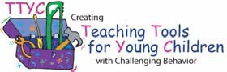

Lentini, R., Vaughn, B.J., & Fox, L. (2005). Teaching Tools for Young Children with Challenging Behavior. University of South Florida.

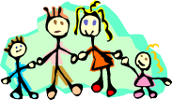
My Preferences:

My teacher wants to know about toys/activities: My Favorite My Least

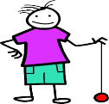
4. My teacher wants to know about people in my life with whom I: Behave Well Have Behavior Problems

My teacher wants to know about foods:
My Favorite My Least

- My teacher wants to know what activities I like:

blocks/Legos | dress up | pretend cooking
computer | coloring | paints
sand table | water table | books
cutting | pasting | play doh
baby dolls | cars/trains | outside play
action figures | real cooking
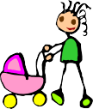

other:
Lentini, R., Vaughn, B.J., & Fox, L. (2005). Teaching Tools for Young Children with Challenging Behavior. University of South Florida.

Technology Websites: From: www.kidssoup.com
https://www.youtube.com/watch?v=zxYsgRsNg2s
School of Rock - My Hero, Zero
http://www.sesamestreet.org/videos?video=1fcedb78-1550-11dd-8ea8-a3d2ac25b65b
Sesame Street Zero
http://www/sesamestreet.org/playlists#media/playlist_56
Sesame Street Zero the Hero Cookie Monster
http://mass.pbslearningmedia.org/resource/20d4485a-cf34-4ffb-9738-a90b2b12aadb/zero-the-hero/PBS Learning Media
http://www.harpercollins.com/childrens/feature/petethecat

Daniel Tiger Goes to School for the First Time
http://mass.pbslearningmedia.org/resource/5ebffaac-bf03-4d82-b0a9-c4f393f9ec7a/5ebffaac=bf03-4d82-b0a9-c4f393f0ec7a/
http://mass.pbslearningmedia.org/resource/34cc6c75-7d27-4efd-a57c-6711cfe1ac31/srarting-school/
http://mass.pbslearningmedia.org/resource/c7e84f48-cd75-4e51-8bf3-4dc636d036be/c7e84f48-cd75-4e51-8bf3=4dc636d036be/
http://mass.pbslearningmedia.org/resource/93a8c4fd-5014-47a4-b0ac-2b5d790042e7/the-morning-routine/
http://mass.pbslearningmedia.org/resource/c7e84f48-cd75-4e51-8bf3-4dc636d036be/c7e84f48-cd75-4e51-8bf3-4dc636d036be/

Social Emotional

CSEFEL http://csefel.vanderbilt.edu

ELL and Special Education Resources:
https://www/wida/us/stadards/EarlyYears.aspx
https://www/engageny.org//resource/scaffolding-instruction-english-language-learners-resource-english-language-arts-and
http://www/p12/nysed/gov/specialed/aim/for specific information on how to obtain student materials that satisfy the National Instructional Materials Accessibility Standard (NIMAS) format.

Additional
pre-kpages.com
pre-kinders.com
abcmouse.com (It is free for teachers)

Other Related Social Emotional Resources: (Use during small group or book area choices)
- Tucker Turtle Takes Time to Tuck and Think - CSEFEL - Use this additional resource for small group or individuals that require more scaffolds for behavior, like self-calming techniques.
- I Can Use My Words! - CSEFEL

Resources for Teachers
- Massachusetts Standards for Social and Emotional Learning and Approaches to Play and Learning for Preschool and Kindergarten (http://www.doe.mass.edu/kindergarten/SEL-APL-Standards.pdf)
- "Strategies for Supporting Social-Emotional Development" - compiled by Martha Robey, MSEd.
- "Taking a Positive Approach to Behavior" - compiled by Martha Robey, MSEd.
- "Activities to Promote Social-Emotional Wellness and Resiliency" - compiled by Martha Robey, MSEd.

Things needed for Module 0

Materials/supplies needed (enough for small groups of 4-5 students):
⃝ Attribute blocks
⃝ Puzzle
⃝ Magnifying glasses
⃝ Magnets
⃝ Feely box
⃝ Beads and string
⃝ Turkey basters
⃝ Sorting mats
⃝ Magnetic letters and numbers
⃝ Stencils of letters, numbers and shapes
⃝ Buckets and shovels
⃝ Play dough
⃝ Play dough tools
⃝ Crayons

Materials/supplies to make, print, or copy:
⃝ Feelings chart
⃝ Visual schedule
⃝ Centers/choice board
⃝ Raccoon puzzle
⃝ Number plates - Write numeral on each plate, place corresponding number of stickers on plate
⃝ Dot cards 0-3
⃝ Matching mat laminated
⃝ Five frame laminated
⃝ 0-3 spinner or number cube
⃝ Animal day/night cards

Social Stories to print out:
⃝ I Can Be a Super Friend
⃝ What We Do in Circle
⃝ Stop or Go Behavior
⃝ Tucker Turtle
⃝ I Can Use My Words

Books for dialogic reading:
⃝ If You Take a Mouse to School - Laura Numeroff
⃝ I Love School - Philemon Sturges
⃝ Pete the Cat: Rocking in My School Shoes -Eric Litwin
⃝ The Kissing Hand - Audrey Penn

Recommended books (optional):
⃝ Llama Llama Misses Mama – Anna Dewdney
⃝ Rex Wreck It – Ben Clanton
⃝ When I Build with Blocks – Niki Alling
⃝ Shapes, Shapes, Shapes – Tana Hoban
⃝ Cubes, Cones, Cylinders and Spheres – Tana Hoban
⃝ Block City – Robert Louis Stevenson
⃝ Books about counting
⃝Books about going to school

Please also see booklist for social and emotional learning topics.

