Student logs in and is immediately presented with the FRA.
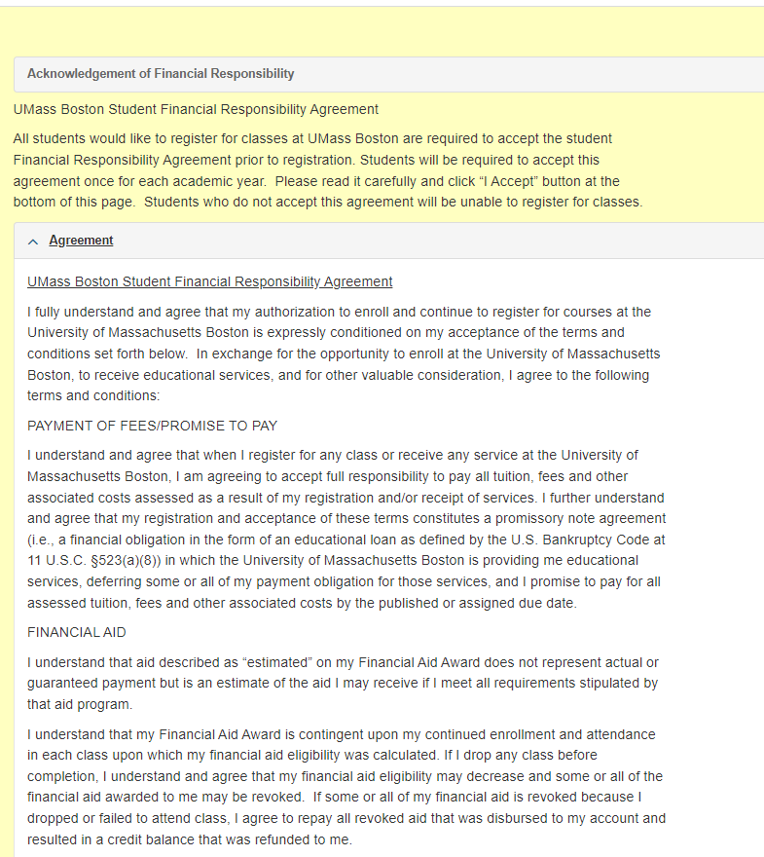
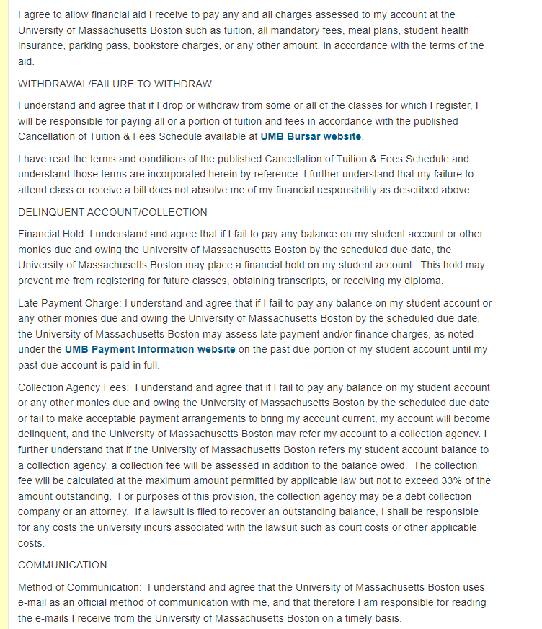
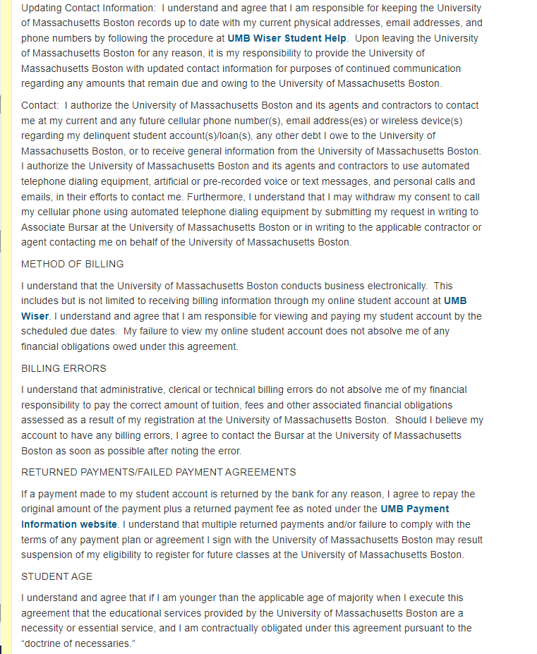
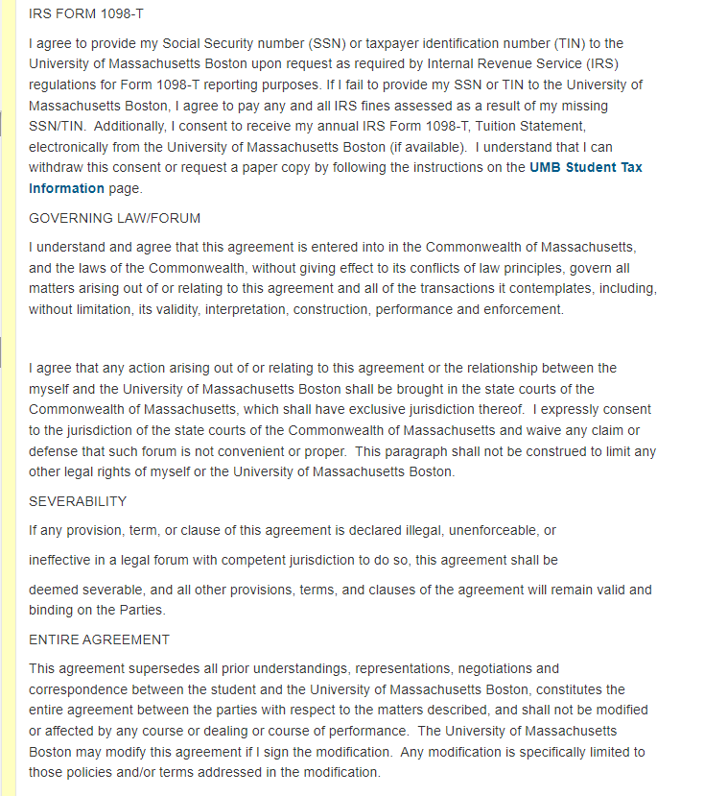
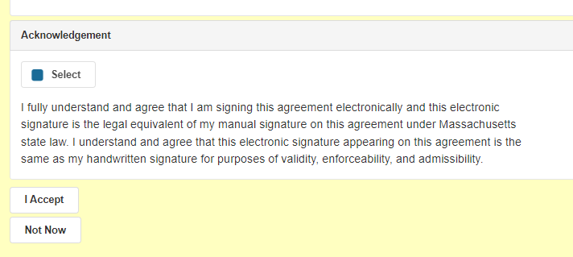
Student can collapse the “Agreement” if they chose to for quicker access to the acceptance:
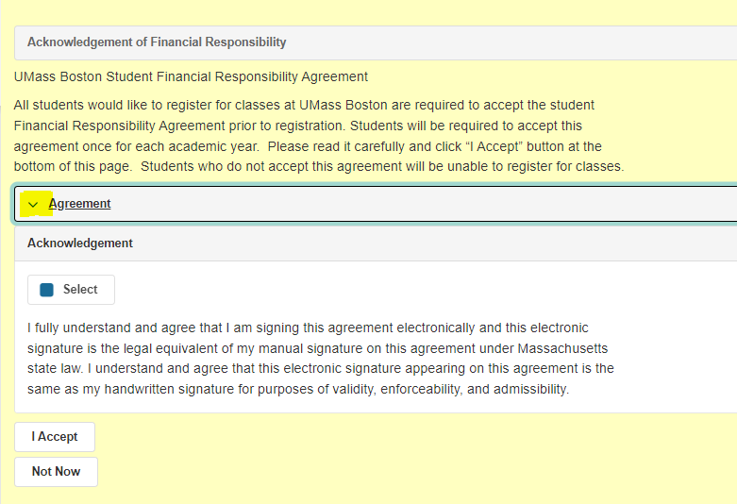

If the student chooses the “Not Now” button
- Student can click “Return to Agreement”- which will return them to the full agreement above
- Student can click “OK, I’ll be back later” – will send them to the Student Center
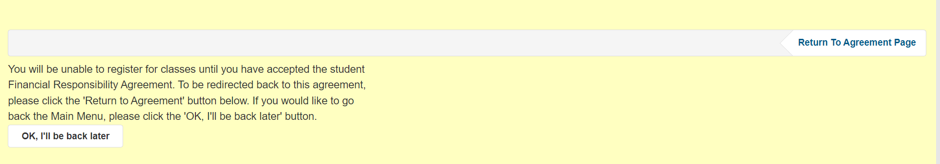
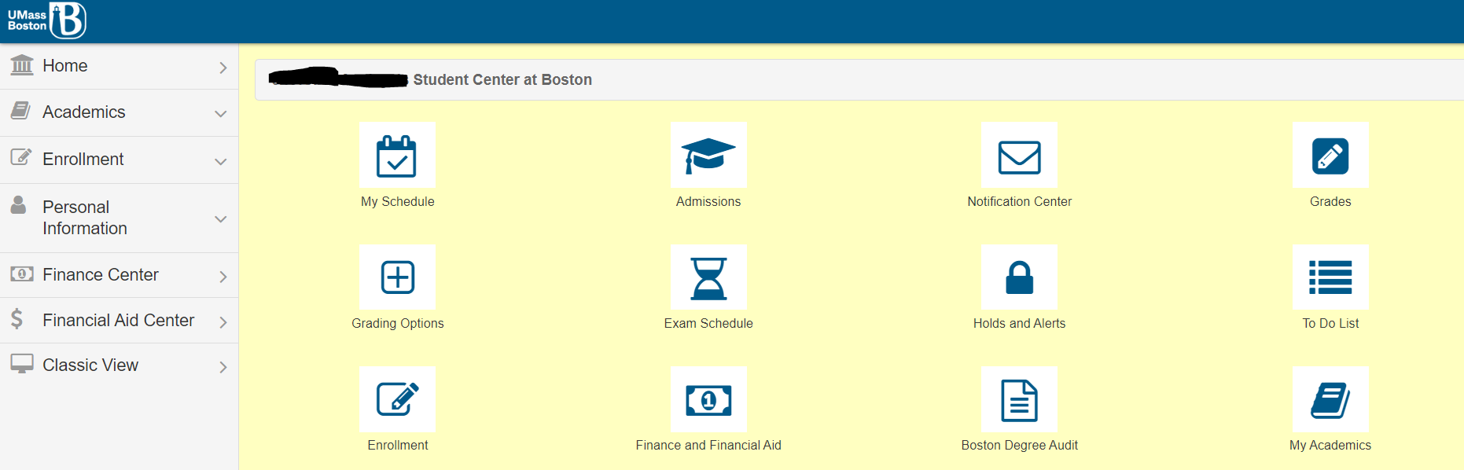

If the student decides to complete the agreement after navigating back to the Student Center:
- Student can re-login and it will present them with the FRA Agreement page again
- Student can navigate to the Student Financial Center and click “Complete Your Financial Responsibility Agreement”
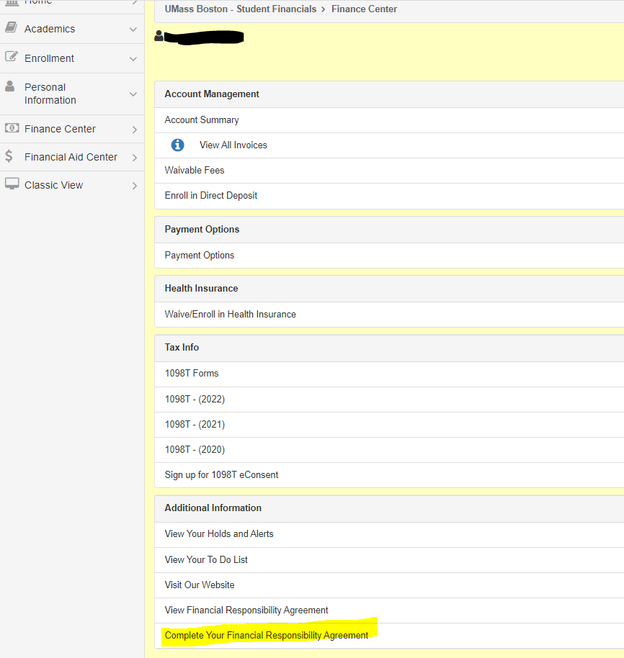
If the student chooses the “I Accept” button
- If they did not click the “Select” they will be prompted with the message to check the box
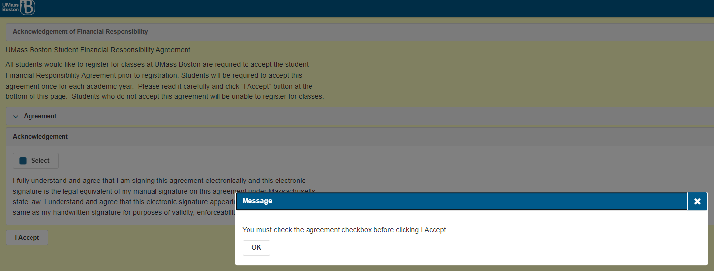
- Upon clicking the “I Accept” button, they will be prompted with a message notifiying they they have accepted the FRA

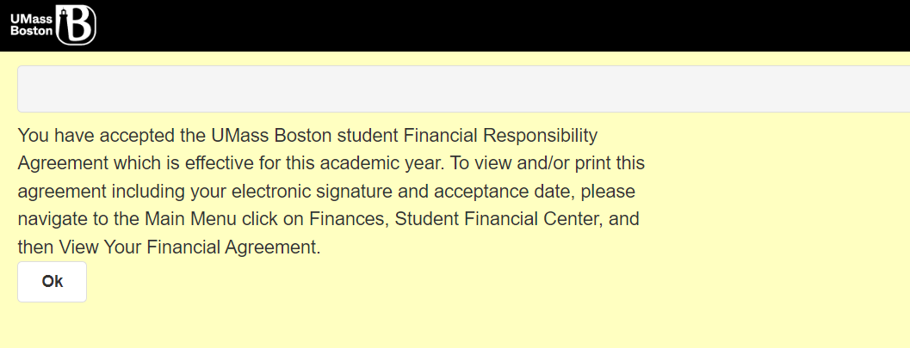

Student can navigate to the Student Financial Center and click “View Your Financial Responsibliity Agreement”
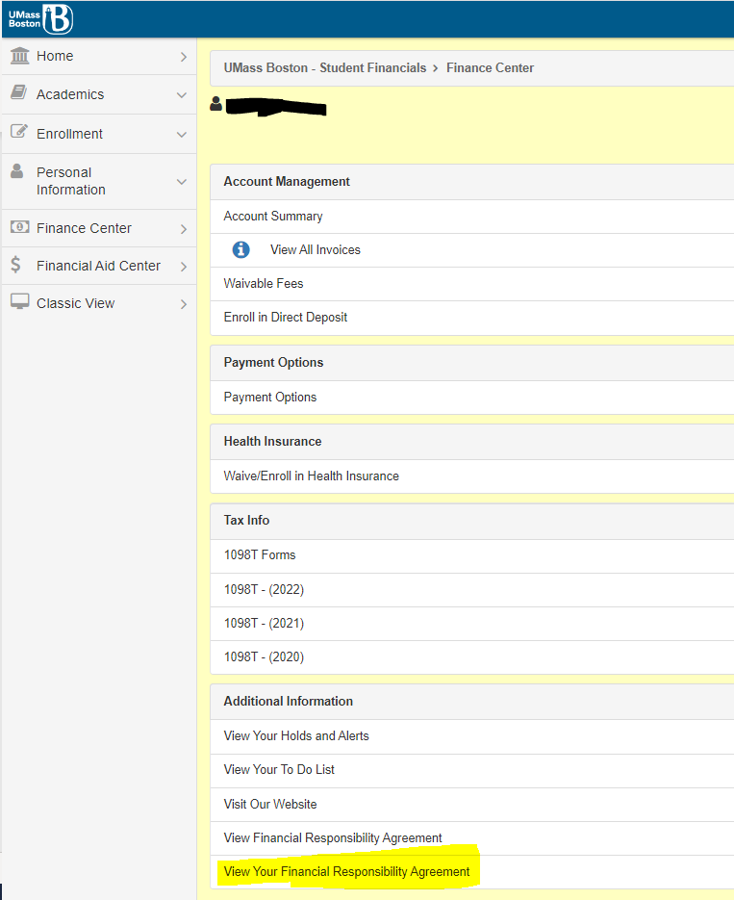

- They will be prompted with a message and should click “View Agreement(pdf)”

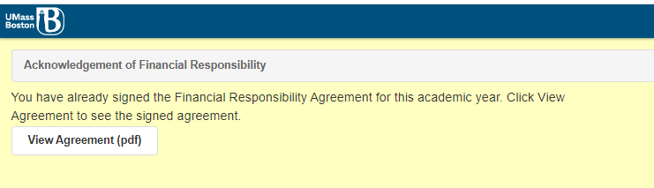

The PDF opens in a new browser window and provide at the end of the PDF:
  - Student Name
  - Student signed date
  - Student ID
  - Year they are signing for

